Sustainability Management of Geopark as Geotourism Destination
Martina Pásková^{1, a *} and Josef Zelenka ^{2,b}
^{1, 2} Department of Recreology and Tourism, University of Hradec Králové, Hradec Králové, Czech Republic
ªmartina.paskova@uhk.cz*, ^{b}josef.zelenka@uhk.cz
Keywords: geotourism, management, sustainability, UNESCO global geoparks, certification.
The increasing interest in and responsibility of ordinary people for the nature and landscape both in their surrounding and globality has not only led to the rise of bottom-up environmental initiatives but also to their support by national, transnational and international institutions (Pásková & Zelenka, 2018a). The "paradigmatic" shift to the participative approach to nature conservation has also led to the emergence and dynamic development of geoparks initiative. This holistic concept of protection (Erikstad, 2013), the presentation, interpretation and sustainable use of geoheritage and other natural and cultural heritage, based on the activity and responsibility of local actors, draws attention of increasing number of states and institutions. Gradually it was developed into the quality label, which is currently under the UNESCO supervision.
Geotourism (Dowling, Newsome, 2006; Farsani et al., 2012; Dowling, 2013) as a environmentally innovative form of tourism has been developing since its origin in accordance with the principles of tourism sustainability (Pásková, Dolejský, 2011; Farsani, Celeste, Costa, 2012; Pásková, 2012; Dowling, 2013). The holistic concept of linking conservation and the presentation of geological, other natural and cultural heritage is reflected in the planned Earth Heritage interpretation (Barrow, 2013), e.g. in the form of the ABC concept (Abiotic, Biotic, Cultural – Dowling, 2013). According to Pásková (2018), the basic principle of geoparks is the implementation of a participative approach to their management. A major impetus for the holistic sustainability of geopark development is the emphasis on integrated quality management. It has become progressively enriched into the form of sustainability management. This is a key feature of the development of UNESCO global geoparks (UGGs), which is reflected in their certification and revalidation schemes as well as in UGG statutes (GGN, 2016; Islam, Ruhanen, Ritchie, 2018) and guidelines.
Geotourism represent a specific form of sustainable tourism (Novelli, 2005; Farsani et al., 2012; Pásková, 2011, 2012, 2014; Dowling, 2013), and geoparks' management can be well considered as a specific form of destination management. Geoparks, however, implement a wider scope of activities; geotourism is just one of them and serves primarily as a tool of environmental education and support of cultural identity of the people living in geopark. Destination management, on the other hand, is professionally specialized in tourism management so that the geopark usually cooperates with the destination management organization competent in its territory.
In the context of recent trends in sustainability management, geopark management and their certification processes development, this chapter analyses the application of selected concepts of sustainability management within UGGs´ certification and networking processes.

Sustainability management
Sustainability management has developed since the 1980s, especially for business environments and later by organizations in general. Initially, it was based on managing their internal processes in order to reduce their environmental impacts, for example, by applying cleaner production methods, ISO 14000 or EMAS (Pásková, Zelenka, 2018a). In addition to formal approaches, an informal approach, referred to as Total Environmental Quality Management (TEQM, e.g. Shen, 1999) has been developed as a follow-up to Total Quality Management (TQM).
However, as Starik and Kanashiro (2013) analyse, the current management theory of the organization does not take sufficient account of the dynamically changing external environment of the company and lacks the consistent link between the organization's management and its environmental and socio-cultural environment.
In order to improve the quality of sustainability management, Starik and Kanashiro (2013) propose their "proto-theory" of organizational sustainability management, based on a consistent system and process approach involving organizations, societies and individuals and the environment (Starik and Kanashiro, 2013:18). Hörisch and Freeman, supplements their approach and Schaltegger (2014) with the emphasis on the development of interest group theory based on the approaches that create common interests stemming from mutual cooperation on sustainability as a shared value among all interest groups. The development of this cooperation is conditioned by education, the creation of values ​​and regulation (Hörisch, Freeman and Schaltegger, 2014: 338-340; Azman et al., 2010). In this form, sustainability management represents a synergic combination of concepts of environmental quality management (Pásková, Zelenka, 2018a, Shen, 1999), participative management (Rolková, Farkašová, 2015), strategic management (Pricop, 2012) and knowledge management (Swan et al., 1999). Current concepts of sustainability management in tourism destinations (specifically in protected areas), include approaches as environmental quality management, participative management, strategic management and knowledge management. The last mentioned approach is closely connected with the adaptive co-management (Islam, Ruhanen, Ritchie, 2018).
Among the most important approaches of tourism sustainability are the integrated management (e.g. Inskeep, 1991), systematic and system management of the destination (e.g. Jakulin, 2016; 2017) and participative management for involving both destination actors and other key tourism stakeholders (Hörisch, Freeman and Schaltegger, 2014). The specifics of application of participative management in tourism were described already in the beginning of the third millennium in Australia (NT Parks & Wildlife Commission, 2002) and they further developed (e.g. for tourism in protected areas, Eagles, Mccool, Haynes, 2002). To control tourism sustainability, it is also important to optimize its impacts, which is to reach an equilibrium in which its positive effects are maximized while minimizing the negative ones (Pásková, 2001, 2012). For that reason, in addition to the aforementioned participative management and strategic management, monitoring of tourism impacts is implemented, which is a helpful instrument for determining the carrying capacity of the destination and its life cycle (Pásková, 2012). This represents one of the many forms of the application of the knowledge management concept and knowledge gained represents an essential support for the tourism impacts management (optimization). Among other approaches applied with aim to manage tourism impacts are visitor management (Zelenka, J., Kacetl, 2013; Leung et al., 2014), specifically for geotourism (Newsome, Dowling, Leung, 2012), advanced information and communication technologies in management (e.g. Cayla, Hobléa, Reynard, 2014) in geoheritage management) and the heritage conservation.

Knowledge management as a specific part of geopark management
Interpretation of geopark territorial values has expanded from the rather passive interpretation of geological heritage to the mostly active interpretation of interconnection of all three components of the Earth's heritage (abiotic, biotic and cultural). This ABC concept (Dowling, 2013; Pásková, 2012, 2014) highlights the interdependence of geodiversity and biodiversity (e.g. Santucci, 2005) with cultural diversity and identity of the local community (e.g. Pásková, 2017, 2018; Palacio-Prieto et al., 2016). Geological values of individual geosites are assessed qualitatively by the description of its geodiversity (Erikstad, 2013) and quantitatively, by pointing the value of geoheritage through the identification of the values of individual geosites (e.g. Fassoulas, Paragamian, Iliopoulos, 2007; Fassoulas. et al., 2012; Forte et al., 2012; Kubalíková, 2013; 2017; Brilha, 2016).
Geopark management includes also other knowledge management approaches, whether it is the sharing of experience and knowledge in the frame of networking (e.g. Farsani, Celeste, Costa, 2012; Shen, 1999), or geopark collaboration with the local community (e.g. Farsani et al., 2014), the education of local residents and visitors (Azman et al., 2010; Fassoulas, Zouros, 2010; Pásková, Řídkošil, 2011) and the way of interpretation of geological, biological and cultural heritage. The sharing of experience and knowledge takes place mainly within the framework of coordination committee and advisory committee meetings, thematic working groups, workshops, conferences, and in the form of a GGN competition concerning examples of good practice held at two-yearly intervals. All these activities are realized in the frame of the coordinative regional networks (European, Asian-Pacific, Latin-American & Caribbean, and African) and Global geoparks network (GGN).
Knowledge management is mainly used in the assessment process of aspiring and revalidated geoparks, when the UNESCO global geoparks' evaluators hand over to geopark representatives their experience and knowledge, concerning geopark management, the conservation, presentation and interpretation of geoheritage, geotourism development and the involvement of the local community in geopark activities. Evaluators have to attend regular workshops and testing organized by aforementioned regional geopark networks and co-organized by UNESCO. In addition to new information and deeper explanation from UNESCO and feedback from the evaluated geoparks, there is a mutual exchange of information and experience among evaluators and their feedback to UNESCO. Quality of knowledge management behind the evaluation/revalidation system is guaranteed by distinguishing and knowledge sharing between senior and junior evaluator. After accomplishment of evaluation, their performance is not only assessed by UNESCO and evaluated geopark, but they also assess each other.

Participative management
Participative management is perceived by Pásková and Zelenka (2018b) as a concept profiting from the positive benefits generated by cooperation which can be characterized “higher potential of know-how, shared values, motivation to promote common goals” (e.g. Rolková and Farkašová 2015). According to them, these values also include sustainability objectives and respect for the specific interests of the organizations involved.
The application of participatory management in tourism represents one of the essential tools of the ensuring the long-term sustainability of tourism at national, regional or local level. They defined tourism participation management as a supervised, gradual and targeted process of involvement of key tourism actors and their groups into the destination activities and management. They mentioned specifically destination information processes, creating common awareness, preserving, transferring and sharing values, preparing joint projects and implementing them, contribution to creating information and knowledge necessary for decision making, developing plans, visions, objectives, alternative strategies and practices, and participating in decision-making and control processes, including monitoring and evaluation of jointly achieved results. The application of participatory management in tourism is elaborated on a theoretical level (e.g. Bramwell, 2010) and verified in practice in locations representing to different destination types and diverse in terms of available resources and internal and external environment. Participatory management applied in the field of protected areas tourism has received a lot of attention (NT Parks & Wildlife Commission 2002; Testers et al. 2005; Testers, Kušová and Bartoš, 2007; Zelenka et al. 2013), where information and participation of local residents is central approach to finding limits for acceptable changes. In destinations striving for the tourism sustainability in the framework of corporate social responsibility, the sharing of values and knowledge is an integral part of the social capital development of the destination (Pásková and Zelenka 2018a: 162). According to Zelenka and Kacetl (2013), participativeness level of management represents an important criterion of the quality of destination, respectively visitor management. A fundamental moment for the application and development of participative management as well as knowledge management is networking, enabling different levels and ways of involvement of destination actors at local, national, regional and transnational level. Networking and its application in participatory tourism management does not represent yet a major research subject in tourism studies (Van der Zee and Vanneste 2015).
The emphasis put on the economic and social benefits brought by geoparks to the regions, mainly generation of new jobs, new economic activities and types of income (Fassoulas, Zouros, 2010; Zouros, Valiakos, 2010; Pásková, Řídkošil, 2011; Farsani, Coelho, Costa, 2011, 2012b; Farsani et al., 2012), stimulation of local agricultural and craft production (Farsani, Coelho, Costa, 2011) and both traditional and innovative regional production (Farsani, Coelho, Costa, 2011). Geoparks can also significantly boost local culture (Farsani et al., 2012; Farsani, Coelho, Costa, 2012a). Many authors emphasize the role of geoparks in sociocultural sustainability in the region and the importance of the role of indigenous peoples (Farsani, Coelho, Costa, 2010; Pásková, Dowling, 2014; Pásková, 2015, 2017, 2018). According to Pásková (2018), it can be very enriching to involve local and indigenous people, their knowledge and experience in the management, operation and activities of the geopark within different bodies (consultative bodies, general assemblies), workshops, conferences, competitions, strategic partnerships, training courses, geosites' interpretation, or geoguide services. This represents an effective combination of participative and knowledge management. The considerable role-play geoparks in the Earth heritage conservation in cooperation with volunteers and the local community (Fassoulas, Zouros, 2010; Farsani et al., 2014).

Certification process as a base of geoparks quality management

Evaluation prerequisites and criteria for the certification of UNESCO global geoparks
Dynamic development of geotourism and UGGs would not be possible without an active involvement geoscientists' erudition, hard work of various NGO's, enthusiasm of many individuals, interest of locals and visitors, UNESCO professional support, coordination of GGN and regional networks. The basic rules and criteria for UGGs' certification process, whose essential components are depicted in Fig. 4, are set in the UGGs' Statutes and Operational Guidelines (UNESCO, 2015). In this document, the UGGs' objectives, their link to key aspects of sustainability management and their relation to the support of regional development are described. In accordance with this normative document and with the aim of gradual and systematic enhancement of the sustainability management, the geopark management body, its strategic planning, financial management, participative management, knowledge management and the use of best practice examples are periodically evaluated (Fig. 1). The UGGs' both self-evaluation and evaluation processes are part of UGGs' knowledge management. In the frame of participative management (e.g. Hörisch, Freeman, Schaltegger, 2014), an active strategic partnership with the key actors is required. If there are some national categories of protected areas or some UNESCO's designation on the territory of the geopark, it is necessary to demonstrate the way of co-operation with the relevant authorities and the way of elimination any kind of mutual overlapping in identity and visibility.
Fig. 1 Principal components of the aspiring geopark evaluation. Source: Pásková and Zelenka (2018b)
An essential condition to be accomplished by the aspiring geopark is not only the recognized value of international importance assigned to its geoheritage but also the existence of sufficient geotourism potential, as well as an adequate quality and degree of its interpretation infrastructure development. Based on the desktop assessment report provided by International Union of Geological Sciences (IUGS), the geoheritage evaluation and related landscape heritage (e.g. Kubalíková, 2013, 2017), is evaluated by independent scientific experts (UGG evaluators). Control and assess the value of internationally significant geosites, as well as occurrence of geological periods, and rock types declared in the geopark application document. In the frame of its knowledge management, a candidate has to classify its sites to distinguish between geosites having prevailingly interpretative (equipped with trails, interpretation panels or leaflets), geosites with scientific significance and those with non-geological (e.g. cultural, agricultural, technical) significance. The UGG has to inventory all these sites through well maintained and updated both database and map.
As a part of the environmental quality management, cooperation care for Earth heritage is also assessed. It includes relevant on research and its popularization, legal conservation and non-legislative bottom-up protection as well as the quality of the presentation and interpretation of Earth heritage are evaluated. The general nature protection as well as geoheritage conservation in the geopark has to be ensured by the legal protection of key both biotic and abiotic (including geological) elements of nature. In these localities protected according to the zoning system of the given protected area as well as in the rest of the geopark area, both quality and intensity of the local inhabitants' education and participation in the geoheritage conservation (Mc Keever, Zouros, 2005; Santucci, 2005; Azman, 2010; Farsani et al., 2014; GGN, 2016; Pásková, Čtveráková, 2017; Pásková, Zelenka, 2018) is also evaluated. According to the ABC concept, geoheritage conservation has to be approached holistically, which means that except of physical protection of geosites by e.g. fencing and natural pavements, it must be integrated into the living nature conservation, monument care and intangible heritage protection. Great emphasis is also put on linking of the interpretation of non-geological heritage (both tangible and intangible – e.g. local toponyms in Crete; Athanasaki, Fassoulas, 2010) with the local geological heritage. This evaluation process reflects the key mission of a geopark at the interpretative level (geoscience knowledge management) and presentation (animation mastery). Furthermore, the importance of cooperation with strategic partners (e.g. local accommodation facilities, travel agencies and geoguides), and other local stakeholders is emphasized as a key component of the participative management. The geotourism developed by aspiring geopark, in collaboration with his strategic partners and local destination management organization, is assessed by both quantity and quality of geotourism products, geotourism infrastructure, and geoguides.
Very important is the proper selection of geopark's territory within which its geodiversity, international geological value its specific features and uniqueness are evaluated according to the UGGs' statutes and operational guidelines (UNESCO, 2015). Based on a detailed map indicating the boundaries of the aspiring geopark and its key geosites, the suitability of delimiting the territory is evaluated, especially in view of the representativeness and diversity of the local geological, geomorphological and other related landscape heritage. It is also assessed how much are these geosites able to enhance geoscience popularization and research as well as Earth heritage interpretation in the frame of education or geotourism.
Regarding the management quality of the aspiring geopark, its managerial structure, geopark management method, staff size and quality and human resources management in general, technical and financial conditions, strategic management and cooperation, approach to the participative management, are evaluated. It is assessed also on the base of the achieved results (e.g. suitability of geopark territory delimitation or modification, visibility and identity level, geoheritage conservation efficiency, geotourism quality, marketing efficiency, acceptance by local population, level of stakeholders’ involvement, or quality of environmental education). Highly valued is cooperation inside of geopark community, involving cooperation with other UGGs, the geopark’s involvement in activities organized or supported by GGN and regional geoparks networks. Especially, sharing of knowledge and experience through networking and mutual exchange is at the core of UGGs' knowledge management (e.g. Mc Keever, Zouros, 2005).
A way of geoheritage interpretation, geopark marketing and visibility are also evaluated as a result of geopark management, achieved during the precertification and recertification (revalidation) period). In the case of revalidated geopark, the accuracy, the extent and the way of using the UGG's logo and the unified design of the geopark, the quality and scope of the interpretative publications and infrastructure, the “welcome boards” on the geopark's access roads are evaluated as well. The geopark's website, its promotional activities and materials, regular participation in tourism trade fairs, social media presentations, mobile applications, geopark's image in media, and its reflection by public are among other assessed components of geopark marketing including its visibility. Marketing and, in particular, the promotion of geopark should be carried out in cooperation with strategic partners, however the use of UGGs' logo has to follow the UNESCO relevant rules.
An important theme, based on the concept of sustainability management, as well as essential for UGGs' concept and discussed at GGN or EGN conferences (e.g. Zouros, N., Valiakos, 2010), is a UGGs' contribution to the implementation of the UN Sustainable Development Goals (SDGs). It is implemented in majority of geoparks by the environmental education of local residents, visitors and other actors as well as raising their awareness of the importance of geoheritage conservation. The UGGs' contribution to the sustainable development on the local and regional levels is conditioned by cooperation with authorities of municipalities and regions the UGGs' territories. This collaboration encourages e.g. responsible tourism based on sharing authentic local life with visitors, support for regional production, especially small farmers and craftsmen, and preference for the use of alternative energy sources. It have to be accompanied by systematic provision of the local informal education in the field of Earth Sciences and related interpretative programs and tools, e.g. interpretation centres, educational publications and games, interactive websites, and mobile applications. This kind of activities, forming components of UGGs' environmental quality management, should take place with the widest possible cooperation of relevant strategic partners as museums, schools (“geo-schools”), NGOs focused on environmental education or individual collaborators and volunteers (“geo-ambassadors”). A contribution to the SDGs' implementation provided by the Bohemian Paradise UGG can serve as a good example (Table 1).
Table 1 An example of implementation of the SDGs by the Bohemian Paradise UGG. Source: Bohemian Geopark UNESCO Global Geopark archive
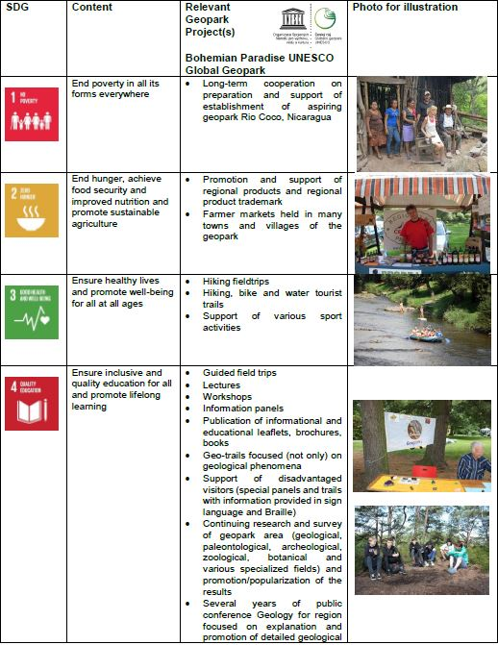
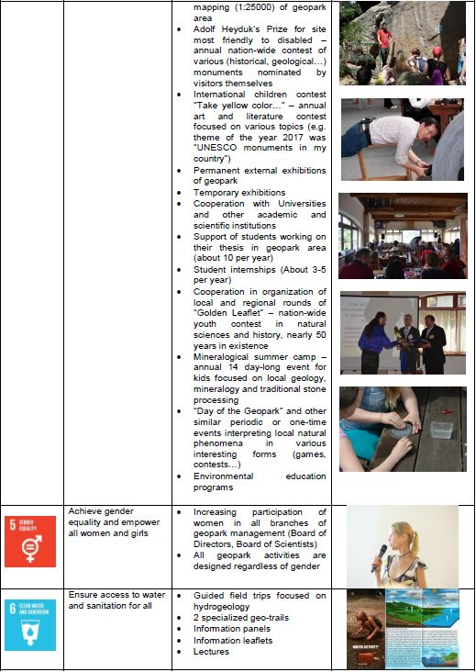
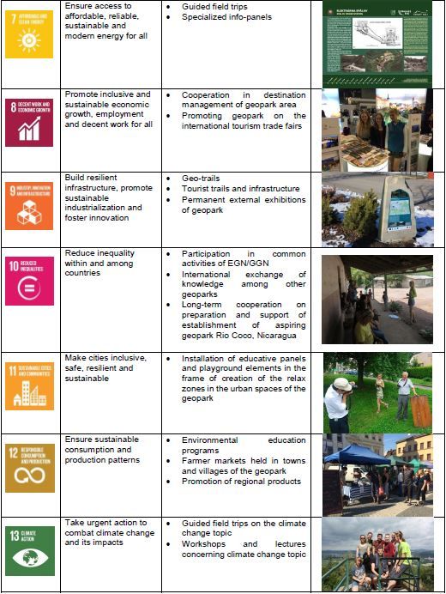
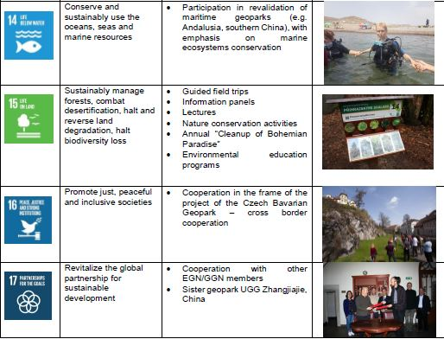

The process of certification and revalidation of UNESCO global geoparks

Application and certification process
The process of UGG establishment is a typical bottom-up initiative in which geopark manager's activity is backed by experience and advice of external bodies (e.g. relevant member states' institutions, or UNESCO) and implemented in the form of realisation of gradual well-prepared steps of the certification process coordinated by UNESCO. The process of preparation of geopark establishment takes several years (usually nearly one decade); an aspiring geopark has to function as a de facto global geopark. On the national level, an important role in the certification process plays the National Geopark Forum / Council (Fig. 3), which coordinates the activities of geoparks in the country and facilitates application and revalidation processes of UGGs in their country. This Forum / Council or another competent authority address UNESCO with an official expression of the intention of a particular territory in its country to aspire on the designation of UGGs. The application document are accompanied by self-assessment is submitted by the management body of the aspiring, both carried out in the prescribed form.
Following the delivery of application dossiers of the aspiring geopark to UNESCO, the evaluation process conducted in the frame of the International Geosciences & Geopark programme (IGGP) begins. The geoscientists selected by IUGS carry out the desktop evaluation and then two independent professional experts selected by UNESCO have to conduct evaluation field mission (one focusing on geosciences and the other on regional development including geotourism). They perform this evaluation mission (Fig. 2) according to the UGGs' Statute and Operational Guidelines (UNESCO, 2015) and guidelines UGGs' evaluators and they have to observe GGN ethic code. Their task is to sum up their field findings compare them with the application document and the self-evaluation provided by aspiring geopark management and write down a comprehensive evaluation report for UNESCO. This procedure is a combination of knowledge management and environmental quality management, which results (evaluation reports) are essential for the discussion and decision-making of the UNESCO Global Geopark Council regarding the aspiring geopark readiness for the UGG certificate award. This Council consists of twelve voting member with proven relevant knowledge and experience and non-voting members including UNESCO Director-General, GGN President as well as representatives of the IUGS Secretary-General and of the IUCN Director-General. If the UGGs Council decides positively, a proposal for the UGG certificate (Fig. 4) award is forwarded to the UNESCO Executive Board. After the endorsement by the UNESCO Executive Board, the certificate is granted to the relevant aspiring geopark (an official awarding takes place at the GGN conference) and the management entity is entitled to use the UGG logo (Fig. 4).
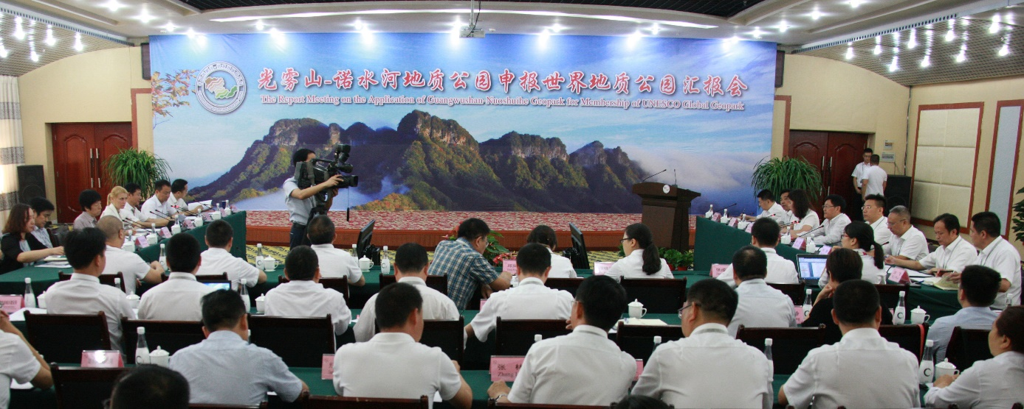
Fig. 2 The final feedback conference of the evaluation mission. Source: Archive of Guangwushan-Nuoshuihe UNESCO Global Geopark (China)
Fig. 3 UNESCO Global Geopark logo. Resource: UNESCO (2018a)
Fig. 4 National Geoparks Council logo. Source: Ministry of the Environment of the Czech Republic (2018) | Fig. 5 The UGG's certificate. Source: Nature Conservation Agency of the Czech Republic (2018)

Revalidation and recertification process
A common and effective part of the certification system is to grant a certificate for a specific period, usually accompanied by a set of recommendations for the next revalidation period. In line with this practice, UNESCO grants the aforementioned just for four years (Fig. 4). At the end of this period, UGG's revalidation process begins. One of the components of the implementation of the environmental quality management, incorporated in accordance with the common procedures used in the certification schemes (see e.g. ISO 9001, ISO 14001), is the requirement for the continuous improvement of management. Therefore, revalidation procedure requires proof of progress performed, and compliance with recommendations resulted from the initial evaluation or the last revalidation). The quality improvement of the implementation the strategic management, financial management, and human resources management. The revalidation process result in one of three variants, which used to be for clarity and ease of communication expressed in colour cards (Box 2). The revalidation process is also based on the revalidation mission, conducted by evaluators after studying of revalidation progress report, self-assessment and other related documents, prepared by revalidated geopark.
Box 1 Classification of UGGs' revalidation output, Source: Pásková and Zelenka (2018b)
- “Green card” means the renewal of the UGG certificate for four years,
- “Yellow card” means the renewal of the UGG certificate just for two years (significant deficiencies in UGG's activities are indicated; UNESCO invites the geopark managing authority in writing to correct the situation during this period, otherwise the UGG certificate will not be updated, it can be followed just by red card),
- "Red card" means the non- renewal of the UGG certificate and it is only issued if during the previous two-year "yellow card" period the revalidated geopark has not addressed by UNESCO.
Evaluators propose in their report which card should be granted to the revalidated geopark and then it is discussed and decided by the UUGs Council.

Discussion of quality of the certification of UNESCO Global Geoparks
The results of the process analysis (Pásková, Zelenka, 2018b) and relevant literature indicate that UGGs´ sustainability management is based on the following six principles (Pásková, Čtveráková, 2017; Pásková, Zelenka, 2018b):
- Delimitation of the territory appropriate for the presentation of the selected Earth heritage of international importance, with a sufficient area allowing support to the regional development and the active involvement of the local population (application of knowledge management and participative management);
- geoheritage conservation, mainly in the form of voluntary bottom-up Earth heritage protection supplemented by top-down nature conservation provided by state (application of environmental quality management and participative management);
- environmental education of the general public including the geoheritage interpretation (Fig. 6) of the geopark based on multidisciplinary approach, e.g. the ABC concept (application of environmental quality management and knowledge management);
- interacting within other national and international programs (including the mutual co-operation with other UGGs) and sharing knowledge, and experience between UGGs through multilevel networking (knowledge management application);
- certification system consisting in an initial evaluation and regular revalidation (application of environmental quality management and knowledge management);
- compliance with the sustainable development principles and goals, active cooperation with strategic partners, strategic planning of individual UGGs and whole networks, revalidation action plans and control (application of strategic management and participative management).

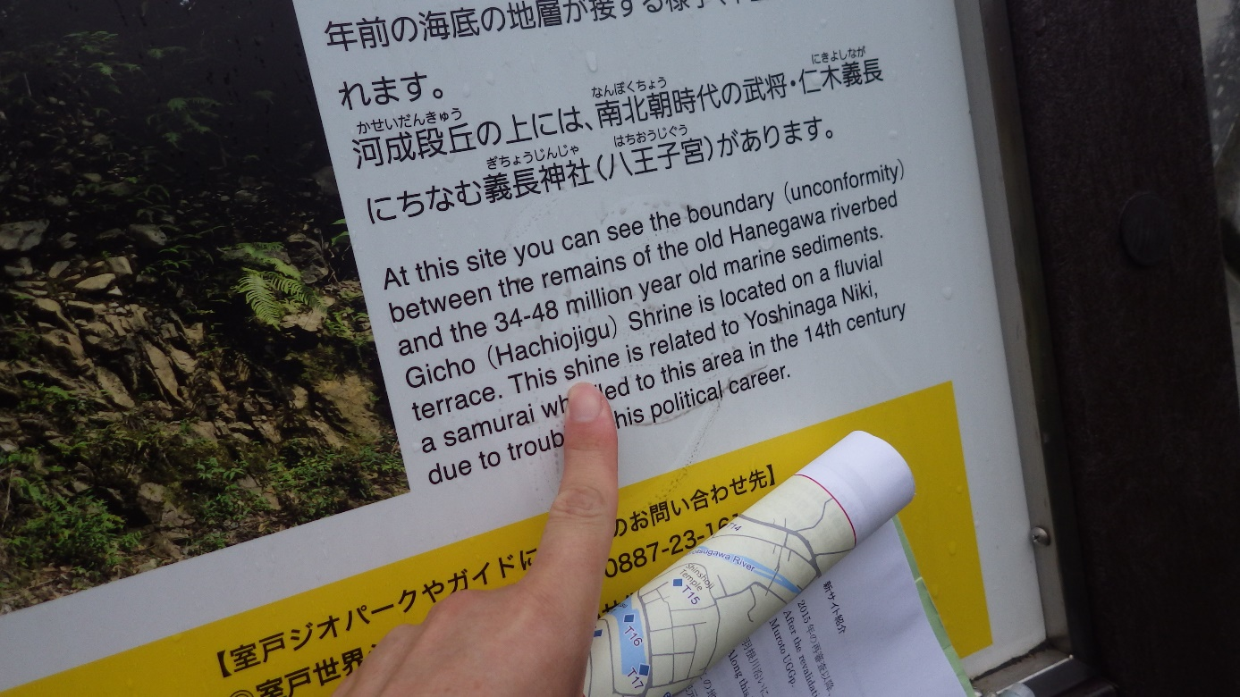
Fig. 6 Verifying the Earth heritage interpretation at the new geosite. Source: Archive of Muroto UNESCO Global Geopark (Japan)
These principles can be clustered into the four approaches to sustainability management, knowledge management, participative management, environmental quality management, and strategic management. As already mentioned, some UGG are serving as destination management organisations. It includes both coordinative and corrective activities, which can be integrated into other cluster. All these clusters of sustainability management of UGGs are illustrated in Fig. 5.
Fig. 7 The key components of the UGGs´ sustainable management. Source: Pásková and Zelenka (2018b)
An overview of how these selected sustainability management concepts are applied in UGGs' certification procedures and networking is provided by Table 1.
According to Pásková and Zelenka (2018b), the UGGs' organizational and institutional evolution evidenced the significant transition from the voluntary network to the official UNESCO designation in the frame of the IGGP. They assume to this transition important changes in the involvement and competences of various subjects and institutions as well as the operational rules and guiding principles. As one of the most important changes, they perceive the decisive role of UNESCO and the higher intensity of involvement of the UNESCO member states authorities. The performance of GGN, regional networks and individual UGGs became more professional.
The UGGs' certification scheme as well as the all the UGGs' fundamental documents stress the role of UGGs in the sustainable development of the region. This is implemented mainly by support of geotourism, “geofood”, local farming in general, local / regional production, as well as by development of strategic partnership. This is in some cases accompanied by the certification scheme developed and implemented by the UGG, when the certificate and logo of “UGG's partner” can be granted to its strategic or other partner on the basis of the selected criteria. The UGG management entity “should be appropriately equipped to address the entire area and should include all relevant local and regional actors and authorities” UNESCO (2018b). The management plan should be agreed upon by all the strategic partners, and it should include “the social and economic needs of the local populations”, protection of their landscape heritage and support their cultural identity as well as “the governance, development, communication, protection, infrastructure, finances, and UGGs' partnerships” UNESCO (2018b).

Table 2 Application of the selected concepts of the sustainability management to the UNESCO Global Geoparks certification and networking process. Source: Pásková and Zelenka (2018b)
Selected concept of sustainability management | Methods of the concept application in the UNESCO global geoparks (UGGs) sustainability management | Weaknesses, risks, and barriers to the concept application in the UGGs sustainability management
Strategic management | - EGN and GGN strategies  - UGGs strategic plans  - Revalidation action plans and control  - Managing authorities of UGGs and regional networks  - 10 focal topics of UGGs  - Strategic plans of the individual UGGs  - Financial planning with 4-year action plans  - Mission of UGGs – EGN/GGN Charter and UNESCO Statutes and Guidelines, GGN Statutes  - Long-term cooperation with destination management | - Time consuming, erudition, project management, fundraising, relationship management, key actors analysis  - Personnel and organizational changes in local governments, national governments, and management of the key relevant institutions  - Difficulty in deploying the management of regional networks (unpaid function)
Participative management | - Involvement of all UGGs into General Assembly  - Involvement of all European UGGs into the Coordination Commission of EGN  - Involvement of the key actors of individual UUGs into their management and activities  - Strategic partnership of individual UGGs | - Time consuming, delays in decision making  - Lower predictability of the behaviour of some key actors  - Distrust and / or reluctance of the local inhabitants and other key actors
Environmental quality management | - Initial evaluation and periodical revalidation of UGGs  - Periodic reporting on UGGs progress  - Annual reporting of UGGs  - Geoheritage management and conservation  - Geohazards management  - Continuous environmental awareness raising of local residents and visitors  - Systematic (ABC) interpretation of the Earth heritage  - Regular organization of the EGN geoparks week | - The difficulty in qualifying and financing UGGs  - Demands on objectivity, qualification, erudition, ethics, and the work of UNESCO evaluators (honorary function)  - Time consuming and workload of both internal and external members of UGGs
Knowledge management | - Thematic working groups of GGN, EGN and other regional networks (e.g. volcanology, palaeontology)  - Biennial GGN conferences and regular conferences of EGN and other regional networks  - Capacitation and mentorship system of UGGs  - Workshops of UNESCO global geoparks evaluators  - Best practice examples awards within GGN  - EGN (and other continents´) Coordination Committee  - GGN Executive Board and General Assembly  - GGN, EGN and other continents´ Advisory Committees  - EGN coordinator and vice coordinator  - National geoparks forums and their regular meetings  - International Intensive Course “UNESCO Global Geoparks and Geoheritage Management”  - Inventory of UGG geosites and their assessment system  - UNESCO cooperation with IUGS on geological evaluation  - Collaboration of UGGs with scientific institutions  - Monitoring of the geotourism impacts  - Knowledge systems of local and indigenous people  - Mapping and assessment of geological values and risks | - Time and finances consuming, demanding language skills  - Ethical and political sensitivity (exploitation of local and especially indigenous inhabitants´ knowledge, violation of the intellectual rights)  - Demanding on collective memory transmission as well as on participation continuity of the persons involved in the networking and evaluation and revalidation procedures
UGGs promote, support and implement geoheritage conservation and related landscape not only in the form of own geosites' management, but also in the cooperation with the various voluntary organizations or state nature conservation institutions. The “international importance” of the geoheritage value of an aspiring geopark is assessed by scientific experts who are members “UGG Evaluation Team” UNESCO (2018a). The Earth heritage in UGGs is interpreted mainly in the frame of geotourism, education, capacitation, and intensive awareness raising. The UGGs' interpretation is specific for its usage of the multidisciplinary ABC concept interlinking mutually abiotic, biotic and cultural Earth heritage components.
The UGGs' certification system includes an initial evaluation and periodic revalidation of the implementation of the six aforementioned UGGs' sustainability management principles as well as the quality of their financial management, marketing (visibility management) and their geotourism products. The UGGs' certification is a continuous process (Fig. 7, Fig. 8) and its important part is the preparation for the certification with experience gained in regular meetings, workshops and conferences of regional networks and GGN. At the same time, the certification is a permanent challenge, as the successful revalidation of UGG is conditioned by the development of participative geopark management and marketing, cooperation with research and educational institutions, and support for regional sustainable development, including support for local small farmers, craftsmen and other producers respecting the region's tradition and landscape. Successful revalidation is also a condition for quality progress and widening of environmental awareness, the interpretation of the Earth heritage, with emphasis on the use of modern information technologies (QR codes, virtual guides, or virtual presentations with the animation of geological development of the territory) and geopark geotourism products.
Fig. 8 Application and evaluation process of the UNESCO Global Geoparks. Source: UNESCO (2018b), Pásková and Zelenka (2018b)

Fig. 9 Revalidation process of the UNESCO Global Geoparks. Source: UNESCO (2018b), Pásková and Zelenka (2018b)
The UGGs' strategic vision is expressed in the UGGs' statutes and operational guidelines, GGN statutes (GGN, 2016) and EGN / GGN Charter. The UGGs' strategic management plans as well as periodic revalidation planning and controlling represent conductive tools of strategic management for all the UGGs. Not only GGN but also regional networks develop and implement their strategies to plan and systematically control their continual progress. The UGGs managing authorities and regional networks are striving to implement ten focal topics of UGGs outlined by UNESCO. Long-term cooperation with destination management organizations working in the geoparks' territories is another example of the strategic management applied by UGGs.
The participative management is at the core of UGG's philosophy based on the bottom-up and networking approaches. The main UGGs' mission consist in dissemination of the Earth heritage knowledge to the local people through their both direct and indirect involvement into the UGGs' activities. The other key actors of UUGs are involved into their management and activities mainly through strategic partnership. The UGGs are certified by UNESCO; however, their performance is co-ordinated through networking on the global, regional and national levels. Within the GGN, its institutional (UGGs representatives), individual, honorary and cooperating members are involved into its General Assembly and in similar way, all the European UGGs are involved into the EGN Coordination Commission activities. Similar participative approach is applied also to coordination of UGGs' activities of UGGs in other regional networks.
The application of environmental quality management seems to be principal mainly in the controlling management component the UNESCO global geoparks. Both initial evaluation and revalidation schemes include control of the progress in the geoheritage protection and management, geohazards management, continuous environmental awareness raising of local residents and visitors, systematic Earth heritage interpretation and annual reporting.
The UGGs apply knowledge management predominantly through their multilevel networking and certification system. The most applied tools include thematic working groups of both EGN and GGN, biennial conferences of global and regional networks, regular meetings of the GGN Executive Board, GGN, EGN and other continental Advisory Committees, EGN Coordination Committee and committees of other regional networks, national geoparks forums and their and workshops of UGGs' evaluators. E.g., the assessment of the geoheritage value of aspiring geoparks “is based on the international peer-reviewed, published research” conducted on the geosites and the scientific experts “make a globally comparative assessment to determine whether the geological sites constitute international value” Ministry of the Environment of the Czech Republic (2018). Other useful knowledge management instruments used by UGGs are represented by GGN best practice awards, an International Intensive Course “UNESCO Global Geoparks and Geoheritage Management”, inventory of UGG's geosites and their assessment system as well as monitoring of the geotourism impacts. UNESCO systematically organises or supports capacitation activities (e.g. workshops, seminars, consultations) including the mentorship missions to aspiring geoparks or emerging geoparks networks. A systematic cooperation with scientific institutions is also very important.

Conclusions
In the context of sustainable development goals (SDOs), geotourism can be perceived as a socially responsible activity generalising except of incomes also substantial environmental education and nature conservation. Geoparks represent areas with systematically managed sustainability. Certification process of geoparks as geotourism destinations is manifesting the viability of application of the selected sustainability management concepts and their various combinations. Management of geotourism sustainability represents an integrated part of it.
The opportunities and risks of geotourism development, together with the obstacles and problems associated with the implementation of the different approaches to the geoparks and geotourism sustainability management should be subject of future interdisciplinary research. It would be also useful to compare differences in the sustainability assessment of geotourism, geo-interpretation and other geo-activities between individual geoparks and their regional networks.

Acknowledgments
This chapter was financially supported by the Faculty of Informatics and Management of the University of Hradec Králové (FIM UHK) within the framework of the Specific Research Project “Information and knowledge management and cognitive science in tourism”. The authors wish to express their thanks to Jan Hruška, FIM UHK student, who assisted with the graphical elements of this study.
References
- Nature Conservation Agency of the Czech Republic (2018). Bohemian Paradise UNESCO Global Geopark certificate, [online], available: http://www.ochranaprirody.cz/res/archive/348/046288.pdf?seek=1488360624.
- Athanasaki, K., Fassoulas, Ch. (2010) Intangible aspects of Geoparks. Local names, toponyms and geoheritage in Crete (Greece), in 9th European Geoparks Conference 2010, Lesvos, Greek.
- Azman, N. et al. (2010). Public Education in Heritage Conservation for Geopark Community, Procedia - Social and Behavioral Sciences. 7, 504-511.
- Barrow, G. C. (2013). Interpretation Planning and its Role in Sustainable Tourism and Visitor Management at Geoheritage Sites. International Journal of Geoheritage. 1(1), 30-38.
- Bramwell, B. (2010). Participative planning and governance for sustainable tourism. Tourism Recreation Research, 35(3), pp. 239-249, doi: 10.1080/02508281.2010.11081640.
- Brilha, J. (2016). Inventory and Quantitative Assessment of Geosites and Geodiversity Sites: a Review, Geoheritage. 8(2), 119–134.
- Cayla, N., Hobléa, F., Reynard, E. (2014). New digital technologies applied to the management of geoheritage, Geoheritage. 6(2), 89–90.
- Dowling, R. K. (2013). Global Geotourism – An Emerging Form of Sustainable Tourism, Czech Journal of Tourism. 2(2), 59-79.
- Dowling, R. K., Newsome, D. (eds.; 2006). Geotourism, Butterworth-Heinemann, Oxford, UK.
- Eagles, P. J. F., Mccool, S. F., Haynes, Ch. D. (2002). Sustainable Tourism in Protected Areas: Guidelines for Planning and Management, Huntingdon Road Cambridge, Cambridge, UK.
- Erikstad, L. (2013). Geoheritage and geodiversity management – the questions for tomorrow, Proceedings of the Geologists' Association. 124(4), 713-719.
- Farsani, N. T. et al. (eds.; 2012) Geoparks and Geotourism: New approaches to Sustainability for the 21st Century, Brown Walker Press, Florida.
- Farsani, N. T., Celeste, O. A. C., Costa, C. M. M. (2012). Analysis of Network Activities in Geoparks as Geotourism Destinations, International Journal of Tourism Research. 16(1), 1-10.
- Farsani, N. T., Coelho, C., Costa, C. (2010). Geoparks as Art Museums for Geotourists, Revista Turismo & Desenvolvimento. 13/14, 567-576.
- Farsani, N. T., Coelho, O. A., Costa, C. M. M. (2012b). Tourism Crisis Management in Geoparks through Geotourism Development, Journal of Tourism and Development. 3(17/18), 1627-1638.
- Farsani, T. N. et al. (2014). Geo-knowledge Management and Geoconservation via Geoparks and Geotourism, Geoheritage. 6(3), 185–192.
- Farsani, T. N., Coelho, C., Costa, C. (2011). Geotourism and geoparks as novel strategies for socio-economic development in rural areas, International Journal of Tourism Research. 13(1), 68–81.
- Farsani, T. N., Coelho, C., Costa, C. (2012a). Geotourism and Geoparks as Gateways to Socio-cultural sustainability in Qeshm Rural Area, Iran. Asia Pacific, Journal of Tourism Research. 17(1), 30–48.
- Fassoulas, C., Paragamian, K., Iliopoulos, G. (2007). Identification and Assessment of Cretan Geotopes, Bulletin of the Geological Society of Greece. 37, 1780 – 1795.
- Fassoulas, C., Zouros N. (2010). Evaluating the Influence of Greek Geoparks to the Local Communities, Bulletin of the Geological Society of Greece. 43 (2), 896-906.
- Fassoulas, Ch. et al. (2012). Quantitative Assessment of Geotopes as an Effective Tool for Geoheritage Management, Geoheritage. 4(3), 177-193.
- Forte, J. et al. (2012). Quantitative evaluation of geodiversity: development of methodological procedures with application to territorial management, Geophysical Research Abstracts. 14, 8739.
- GGN (2016). The Global Geoparks Network Statutes, [online], available: http://globalgeoparksnetwork.org/wp-content/uploads/2016/07/GGN-Association-Statutes-FINAL-SEPTEMBER-2016.pdf.
- Hörisch, J., Freeman, R. E., Schaltegger, S. (2014). Applying Stakeholder Theory in Sustainability Management. Links, Similarities, Dissimilarities, and a Conceptual Framework, Organization & Environment. 27(4), 328-346.
- Inskeep, E. (1991). Tourism planning: an integrated and sustainable development approach. Van Nostrand Reinhold, New York.
- Islam, W., Ruhanen, L., Ritchie, B. W. (2018), Adaptive co-management: A novel approach to tourism destination governance?, Journal of Hospitality and Tourism Management, 37, 97-106.
- Jakulin, T. J. (2016). Systems approach for contemporary complex tourism systems, International Journal for Quality Research. 10(3), 511-522.
- Jakulin, T. J. (2017). Systems Approach to Tourism: A Methodology for Defining Complex Tourism System, Organizacija. 50(3), 208–215.
- Kubalíková, L. (2013). Geomorphosite assessment for geotourism purposes, Czech Journal of Tourism. 2(2), 80-104.
- Kubalíková, L. (2017). Mining Landforms: An Integrated Approach for Assessing the Geotourism and Geoeducational Potential, Czech Journal of Tourism. 6(2), 131-154.
- Leung, Y-F. et al. (eds.; 2014) Tourism and Visitor Management in Protected Areas. Guidelines for sustainability, World Headquarters, Gland, Switzerland.
- Mc Keever, P. J., Zouros, N. (2005). Geoparks: Celebrating Earth heritage, sustaining local communities, Episodes. 28(4), 274-278.
- Ministry of the Environment of the Czech Republic (2018). Geoparky (Geoparks). [online], available: https://www.mzp.cz/cz/geoparky.
- Newsome, D., Dowling, R., Leung, Y-F. (2012). The nature and management of geotourism: A case study of two established iconic geotourism destinations, Tourism Management Perspectives. 2-3, 19–27.
- Novelli, M. (ed.; 2005), Niche tourism: contemporary issues, trends and cases, Butterworth-Heinemann, Oxford, UK.
- NT Parks & Wildlife Commission (2002). Public Participation in Protected Area Management Best Practice. [online], Available: https://www.environment.gov.au/system/files/resources/45209a20-1ab1-40d1-aa26-cf4838948782/files/public-participation.doc.
- Palacio-Prieto, J. L. et al. (2016). Erosion, Culture and Geoheritage; the Case of Santo Domingo Yanhuitlán, Oaxaca, México, Geoheritage. 8(4), 359-369.
- Pásková, M. (2011): Geoturismus a ekoturismus - Fascinace krajinou (Geotourism and ecotourism – fascination by landscape). in Výzvy a hrozby ekoturismu a geoturismu pro ochranu biodiverzity a geodiverzity (Challenge and threads of ecotourism for the biodiversity and geodiversity conservation)) Telč, Czech Republic, 15-28.
- Pásková, M. (2001). „Udržitelný rozvoj“ cestovního ruchu („Sustainable“ Tourism Development), Geografie – Sbornik CGS. 106(3), 178-195.
- Pásková, M. (2018).Can Indigenous Knowledge Contribute to the Sustainability Management of the Aspiring Rio Coco Geopark, Nicaragua?, Geosciences. 8(8), 277.
- Pásková, M., Čtveráková, I. (2017). Geoparky a jejich role v ochraně přírody a krajiny (Geoparks and their role in nature and landscape conservation), Ochrana přírody, 4, 38 - 41.
- Pásková, M., Dolejský, V. (eds.; 2011), Výzva a hrozby ekoturismu pro ochranu biodiverzity a geodiverzity (Challenge and threads of ecotourism for the biodiversity and geodiversity conservation), Telč, Czech Republic.
- Pásková, M., Dowling, R. K. (2014). The usage of local and indigenous knowledge in the management of geotourism destinations. in 14th International Multidisciplinary Scientific Geoconference SGEM 2014, Geoconference on Ecology, Economics, Education and Legislation. Ecology and Environmental Protection. Albena, Bulgaria, 805 – 812.
- Pásková, M. (2012). Environmentalistika cestovního ruchu (Tourism Environmentalism), Czech Journal of Tourism. 1(2), 77-113.
- Pásková, M. (2014). Interpretace krajiny v geoparcích (Landscape interpretation in geoparks). in Geoparky ČR Možnosti ochrany geodiverzity (Geoparks of the Czech Republic Geoheritage conservation options). Brno, Czech Republic.
- Pásková, M. (2014). Koncept Gaia a geoparky (Gaia concept and geoparks). 2. Konference národních geoparků, Doksy, Czech Republic, 44-55.
- Pásková, M. (2017). Local and Indigenous Knowledge Regarding the Land Use and Use of Other Natural Resources in the Aspiring Rio Coco Geopark, IOP Conference Series: Earth and Environmental Science, 95(5), 1-10.
- Pásková, M., Řídkošil, T. (2011). Geoparks and geotouristic educational trails. In 10th European Geoparks Conference, Langesund, Norway, 99.
- Pásková, M. (2015). The potential of indigenous knowledge for Rio Coco Geopark Geotourism. Elsevier B.V., Procedia Earth and Planetary Science. 15, 886-891.
- Pásková, M., Zelenka, J. (2018b). Sustainability Management of UNESCO Global Geoparks. Sustainable Geoscience and Geotourism, 2, 44-64.
- Pásková, M., Zelenka, J. (2018). Společensky odpovědný cestovní ruch (Social Responsible Tourism). IDEA Servis, Prague, Czech Republic.
- Pricop, O. C. (2012). Critical Aspects in the Strategic Management Theory, Procedia - Social and Behavioral Sciences. 58, 98-107.
- Rolková, M., Farkašová, V. (2015). The Features of Participative Management Style, Procedia Economics and Finance. 23, 1383-1387.
- Santucci, V. (2005). Historical Perspectives on Biodiversity and Geodiversity, Geodiversity & Geoconservation. 22(3), 29-34.
- Shen, T. T. (1999). Total environmental quality management. in Industrial Pollution Prevention. Environmental Engineering. Springer, Berlin, Heidelberg, Germany, 81-139.
- Starik, M., Kanashiro, P. (2013). Toward a Theory of Sustainability Management: Uncovering and Integrating the Nearly Obvious, Organization & Environment. 26(1), 7-30.
- Swan, J. et al. (1999). Knowledge management and innovation: networks and networking, Journal of Knowledge Management. 3(4), 262-275.
- Těšitel, J., Boháč, J., Matějka, K., Bartoš, M., Kušová, D., & Kopáčková, M. (2005). Participativní management chráněných území – klíč k minimalizaci konfliktů mezi ochranou biodiversity a socioekonomickým rozvojem místních komunit (Participatory management of protected areas - the key to minimizing conflicts between biodiversity conservation and the socio-economic development of local communities). Závěrečná zpráva projektu VaV/610/03/03, Ústav ekologie krajiny AV ČR, České Budějovice,
- Těšitel, J., Kušová, D., & Bartoš, M. (2007). Šetrný turismus v biosférických rezervacích – nástroj formování sítí spolupráce: případová studie Biosférické rezervace Šumava (Green tourism in biosphere reserves - a tool for establishment of cooperation networks: a case study of the Šumava Biosphere Reserve). Úřad vlády Korutan, Klagenfurt, SRN, 32 str.
- UNESCO (2018a). Application Process for aspiring UNESCO Global Geoparks. [online], available: http://www.unesco.org/new/en/natural-sciences/environment/earth-sciences/unesco-global-geoparks/application-process/.
- UNESCO (2018b). Fundamental Features of a UNESCO Global Geopark. [online], available: http://www.unesco.org/new/en/natural-sciences/environment/earth-sciences/unesco-global-geoparks/fundamental-features/.
- UNESCO (2015). Statutes and Operational Guidelines for UNESCO Global Geoparks. [online], Available:http://www.unesco.org/new/fileadmin/MULTIMEDIA/HQ/SC/pdf/IGGP_UGG_Statutes_Guidelines_EN.pdf.
- Van der Zee, E., & Vanneste, D. (2015). Tourism networks unravelled; a review of the literature on networks in tourism management studies. Tourism Management Perspective. 15, pp. 46-56, doi: 10.1016/j.tmp.2015.03.006.
- Zelenka, J. Těšitel, J., Pásková, M., & Kušová, D. (2013). Udržitelný cestovní ruch. Management cestovního ruchu v chráněných územích (Sustainable tourism. Management of tourism in protected areas), Gaudeamus Hradec Králové, 327 p.
- Zelenka, J., Kacetl, J. (2013). Visitor management in protected areas, Czech Journal of Tourism. 2(1), 5-18.
- Zouros, N., Valiakos, I. (2010). Geoparks Management and Assessment, Bulletin of the Geological Society of Greece. 43, 965-975.

