A Decade of System Dynamics Modelling for Tourism: Systematic Review
Marek ZANKER¹* and Kamila ŠTEKEROVÁ²
¹ University of Hradec Králové, Hradec Králové, Czech Republic; Marek.Zanker@uhk.cz
² University of Hradec Králové, Hradec Králové, Czech Republic; Kamila.Stekerova@uhk.cz
* Correspondence: Marek.Zanker@uhk.cz
Abstract:
BACKGROUND: Global rapid growth of tourism requires innovative methods of exploration of its complexity. Researchers and stakeholders can benefit from computational modelling approaches, including system dynamics models. OBJECTIVE: A systematic review of system dynamics models in tourism following the PRISMA guideline was undertaken. The review was focused on (1) which tourism-related topics were studied, (2) what were the purpose and the temporal scale of models, (3) what main variables and diagrams were used. METHOD: Scientific databases were searched to identify contributions from 2010-2019; finally, 46 publications were selected as relevant. RESULTS: Thematically, the papers focused on marine tourism, negative impacts of tourism, sustainable tourism, low-carbon economies, decision making, and policy making, and planning for tourism in a broad sense. From the modelling perspective, stock and flow diagram and causal loop diagrams were presented in most of the papers, while systems archetypes were rarely used. CONCLUSIONS: System dynamics models have the potential to support research in the field of tourism. The number of papers grows significantly, and the attention of researches moves from case studies to sustainable tourism, negative impacts of tourism and how to manage them.
Keywords: Tourism; System dynamics model; Systematic review
JEL Classification: Z30; Z32; C39

- Introduction
Tourism was defined as the temporary, short-term movement of people to destinations outside the places where they normally live and work and their activities during the stay at each destination. It includes movements for all purposes (Beaver, 2002). Nowadays, tourism is a highly important part of an economy. On the other hand, tourism is accompanied with negative externalities such as overcrowding, a decline of living standards of locals, high demand for goods and services, pollution and devastating of natural resources, and more. Human society and tourism can be understood as a complex system and the process taking place in it. Therefore, it is possible to apply various computational modelling approaches including models of system dynamics.
System dynamics (SD) helps us to understand the nonlinear behaviour of complex systems over time (Forrester 1961, 1969). To achieve this, models are developed using stocks, flows, internal feedback loops, table functions, and time delays. These artefacts are composed of two main types of diagrams: Stock and Flow Diagram (SFD) and Causal Loop Diagram (CLD). Typically, CLP captures cardinal variables of the system and defines relationships between them. A Systems Archetypes is a universal type of CLD, well applicable in most domains. SFD capture the dynamics of systems, it might be used for predicting the future behaviour of the system, evaluating scenarios, testing extreme settings, boundary testing or sensitivity analysis.

2. Methodology
A systematic review following the PRISMA guideline was managed in order (1) to map the decade of system dynamics modelling in tourism and (2) to identify new research opportunities. Three questions were sought:
- Which tourism-related topics have already been studied using the system dynamics modelling approach?
- What were the purpose and the temporal scale of models?
- What modelling platforms and what system dynamics diagrams were applied?
The search was undertaken using the scientific databases (Scopus, Scinapse, Science Direct, Google Scholar, ACM Digital Library, LENS). The review includes full texts published in English. The search was conducted in September-December 2019. We included articles published within a decade (2010-2019). The selection criteria and data collection strategy focused on two main topics: system dynamics and tourism. Cross-searching was carried out using search terms tourism, system dynamics model, system dynamics approach, system thinking, stock and flow diagram, causal loop diagram, system archetype (few queries are presented in Table 1).
Table 1. Search in databases
Database | Query | Results
Scopus | TITLE-ABS-KEY ( "system dynamics" AND "tourism" ) AND ( LIMIT-TO ( DOCTYPE , "ar" ) ) AND ( LIMIT-TO ( LANGUAGE , "English" ) ) | 67
Scinapse | "system dynamics" and "tourism" | 40
Google Scholar | allintitle: tourism "system dynamics" | 37
LENS | ( Title: ( tourism "system dynamics" ) OR ( Abstract: ( tourism "system dynamics" ) OR ( Keyword: ( tourism "system dynamics" ) OR Field of Study: ( tourism "system dynamics" ) ) ) )  (Filtering: journal articles) | 87

Abstract and keywords of papers were screened to reject papers we identified as not fulfilling our inclusion criteria. Full-text papers were included if they satisfied requirements as follow: tourism-related theme (including management of tourism, destination management, development of tourism, negative impacts of tourism, and/or complexity of tourism, tourism case studies) and application of system dynamics modelling (including systems archetypes, stock and flow diagram, causal loop diagram, and/or system dynamics equations).
We used bibliometric networks for meta-analyses. We chose VOSviewer as software for quantitative synthesis. We focused on the change of keywords related to tourism over time. For that, the keywords related to system dynamics were extracted. VOSviewer allowed us to use overlay visualization, which captures the timeline of selected variables. Items for meta-analysis were extracted from Scopus records.

3. Results

Study selection
We identified 231 results from scientific databases. After removing duplicates, we get 128 papers, from which 61 papers were passed to the stage of full-text assessment for eligibility (the rest of 15 full-text papers were rejected). Finally, we obtained 46 papers suitable for both qualitative and quantitative synthesis. The whole process is shown in Figure 1.
Studies selected are presented in Table 2 in descending order by date of publication. The majority (70%) of studies were published within the last five years (2015-2019), more than one third (39%) of papers were published 2018-2019.
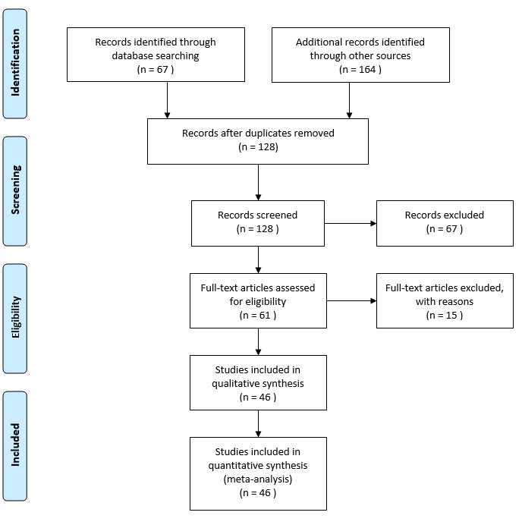

Figure 1. PRISMA flow diagram

Results of individual studies
The largest proportion of papers was focused on sustainable tourism. Typically, authors tested the impact of different protentional policies on the state of the environment and ecotourism demand, see e.g. (Aliani et al. 2018).
(Zhang et al. 2015) explored sustainable tourism in Tibet under different scenarios up to 2050 through CLD and SFD, outputs of the simulation are employment caused by tourism, the value of tourism enterprise, pollution, and the number of visitors.
(Nguyen and Bosch 2013) identified key variables of sustainability in a touristic area in the Cat Ba Biosphere Reserve Vietnam; for that purpose, authors created CLD and applied systems archetypes such as fixes that fail (tourism development), tragedy of the commons (carrying capacities in tourism), shifting the burden (international aid).
(Xing and Dangerfield 2011) focused on the sustainability of mass tourism within island economies. Authors created complex SFD aimed at transport, number of visitors, water and energy supply, waste, and accommodation capacities. Outputs of the simulation were the prediction of the total number of visitors, the impact of tourism on prices, the requirement of new accommodation capacities for 720 months under different scenarios. (Widhianthini 2017) aimed at sustainable planning of touristic villages in Bali in cooperation with local institutions, simulation outputs were the prediction of areas of paddy fields, settlements, green space, and sacred places up to 2030 under several scenarios.
(Nugroho et al. 2019) focused on the sustainability of marine protected areas in the case study of Pieh marine park. Their first SFD captured renewable resources, non-renewable resources, and pollution, while CLD showed relationships between main factors of the marine park (fish population number of visitors, pollution, condition of coral reef). The main SFD connected the main variables of the marine park. The simulation was developed to predict fish and coral populations and pollution up to 2040 under different scenarios.
Similarly, (Vugteveen et al. 2015) studied the socioecological system in the Dutch Wadden Sea region through the model of sustainable fisheries and the model of tourism. The touristic sub-model showed variables measuring the number of visitors, their satisfaction, proportions of fauna and flora, investments in tourism, and sustainability.
(Alcalá et al. 2015) focused on the sustainability of groundwater in an agricultural and touristic area, with the case study of Amtoudi Oasis in Marocco. Their CLD captured the hydrological-economic model and water management. The output of the simulation was the prediction of the number of visitors and the local population for the next 100 years.
Few papers discussed tourism in general; for example (Lu et al. 2019) analysed ecological system security in the case study of the coastal tourist city of Dalian in China. CLD showed relationships between variables related to tourism, economics, and the environment. SFD mainly focuses on GPD, the number of visitors, and population size. Outputs of the simulation are the prediction of the number of visitors, income from tourism, and marine pollution up to 2028 under three different scenarios.
Other papers studied seaside tourism. (You et al. 2018) focused on landscape changes in coastal areas of South Korea. SFD was used to show changes in areas of a coastal sand dune, coastal grassland, coastal forest in relation to tourism infrastructure up to 2054. The authors created two different scenarios: the first one was focused on the erosion of land and the value of ecosystem services. The second scenario was modified to address the impact of the landscape plan and its impact on ecosystem services.
(Chiu et al. 2019) created a system dynamics model to simulate land use of the Chiku coastal zone in Taiwan. The model was focused on the long-term period, and the main goal of the model was to analyse and to improve regional carbon balance. Outputs of the simulations were the prediction of land use, population, tourism, and carbon dioxide absorption and emissions up to 2065.
(Shen 2019) analysed recreation opportunities of Long Island Marine Stone Forest Park. The model was validated through a data survey. The output of the simulation was the prediction of the number of visitors up to 2025.
Only a minority of papers used system dynamics for decision making. (Tan et al. 2018) created a decision support system based on the system dynamics model of sustainable tourism, with the case study of the coastal zone in Cijing Kaohsiung in Taiwan. Both CLD and SFD showed main forces related to tourism and pollution in the coastal zone. Outputs of the simulation were the tourism area, number of visitors, size of local population, state of ecosystem, and economic value index under different scenarios. Outputs of the simulation supposed to improve the decision making of stakeholders.
Negative impacts of tourism were studied by (Phan et al. 2016), (Koenigstein et al. 2016) or (Walsh and Mena 2014). For example (Phan et al. 2016) analysed the conservation status and viability of the critically endangered Cat Ba Langur, CLDs showed the conservation status of the monkeys, forest habitats and species population, and the international help.
The impact of ocean warming on the Barents Sea region was described by (Koenigstein et al. 2016): system dynamics model focused on changes in ocean life and its impact on fisheries, tourism, and recreation, the output of the simulation was a prediction of the amount of the biomass inside an area such as Herring, Seals, and Krill, up to 2075 under different scenarios. Furthermore, the authors predicted economic, political, and environmental factors.
Some papers explored waste production caused by tourism. (Estay-Ossandon and Mena-Nieto 2018) studied municipal solid waste generation in touristic islands with an application on a case study of the Balearic Islands. The study predicated the solid waste production by locals and visitors up to 2030 under several scenarios.
(Kapmeier and Gonçalves 2018) explored the waste production through the case study of Maldives. SFD showed economic growth and environmental pollution; the main variables were the number of visitors, amount of waste, and tourism demand and supply. Furthermore, the waste sub-model was processed in detail. Outputs of the simulation were the prediction of tourists per year, revenue per year, and the amount of waste per year up to 2050 under several scenarios.

Table 2. Studies selected
 | Citation | Domain | Purpose | Results, outputs, variables |  | Temporal scale | Scenarios | Platform | SD artefacts
1 | (Brennan et al. 2019) | Seaside tourism | Increase literacy | Visitors, accommodation |  | 30 Years | No | Own | CLD, SFD
2 | (Yin et al. 2019) | Planning | Study the safety of overcrowded areas | Identification of feedback loops |  | Not specified | No | Vensim | CLD
3 | (Nugroho et al. 2019) | Sustainable tourism | Improve the effectiveness of sustainability area | Number of visitors, pollution |  | 2003-2040 | No | Vensim | CLD, SFD
4 | (Chiu et al. 2019) | Seaside tourism | Simulate land use | Land use |  | 2000-2070 | Yes | Vensim | CLD
5 | (Lu et al. 2019) | Tourism in general | Analyse ecological system security | Number of visitors, income, pollution |  | 2001-2028 | Yes | Vensim | CLD, SFD
6 | (Shen 2019) | Seaside tourism | Analyse the potential of the destination | Number of visitors |  | 2013-2025 | No | Not specified | CLD
7 | (Cheng et al. 2019) | Destination management | Find out the possibility of land use | Land use |  | 2011-2025 | No | Vensim | SFD
8 | (Novani et al. 2019) | Tourism in general | Improvement of tourism | Number of visitors, their satisfaction |  | 2013-2023 | Yes | Powersim | CLD
9 | (Haraldsson and Ólafsdóttir 2018) | Destination management | Analyse destination and visitors | Identification of feedback loops |  | Not specified | No | Not specified | CLD
10 | (Aliani et al. 2018) | Sustainable tourism | Predicate future of ecotourism | Population, infrastructure |  | 2005-2025 | Yes | MapSys | SFD
11 | (You et al. 2018) | Seaside tourism | Show change in the landscape | Land use |  | 2014-2054 | Yes | Stella | SFD
12 | (Tegegne et al. 2018) | Destination management | Show image of Ethiopia | Number of visitors |  | Not specified | No | Vensim | CLD, SFD
13 | (Estay-Ossandon and Mena-Nieto 2018) | Waste production | Show main producers | Waste production |  | 2000-2030 | Yes | Vensim | SFD
14 | (Kapmeier and Gonçalves 2018) | Waste production | Analysed the waste production | Number of visitors, waste production |  | 1979-2050 | Yes | Vensim | SFD
15 | (Bempah 2018) | Destination management | Analyse tourism in the national park | Number of visitors, income, land-use |  | 2008-2029 | Yes | Powersim | CLD, SFD
16 | (Mona 2018) | Tourism in general | Study visitors of Cape Town | Number of visitors |  | 2015-2055 | No | Stella | SFD
17 | (Sampedro et al. 2018) | Island tourism | Study the food-supply system in Galapagos | Tourism, labor, consumption |  | 2012-2037 | Yes | Vensim | SFD
18 | (Tan et al. 2018) | Sustainable tourism | Decision support system | Number of visitors, population size |  | 30 years | Yes | Stella | CLD, SFD
19 | (Widhianthini 2017) | Sustainable tourism | Sustainable planning | Land use, water use |  | 2009-2030 | Yes | Powersim | SFD
20 | (Matthew et al. 2017) | Low carbon policy | Analyse the impact of low-carbon law | Electricity use |  | 2005-2050 | Yes | Vensim | CLD
21 | (Phan et al. 2016) | Negative impacts | Analyse the state of endangers animal | Identification of feedback loops |  | Not specified | No | Vensim | CLD, archetypes
22 | (Koenigstein et al. 2016) | Negative impacts | Analyse the Barents Sea area | Amount of ocean creatures |  | 2015-2075 | Yes | Stella | CLD, SFD
23 | (Halioui and Schmidt 2016) | Tourism in general | Analysis of tourism  sector in Tunisia | Recognition of feedback loops |  | Not specified | No | Vensim | CLD
24 | (Jere Jakulin 2016) | Agritourism | Decision Support System | Number of visitors, level of agritourism |  | Not specified | No | Powersim | CLD, SFD
25 | (Alcalá et al. 2015) | Sustainable tourism | Analyse the state of underground water | Number of visitors, population size, |  | 100 years | Yes | Not specified | CLD
26 | (Zhang et al. 2015) | Sustainable tourism | Planning sustainability in Tibet | Number of visitors, employment |  | 2000-2050 | Yes | Vensim | CLD, SFD
27 | (Vugteveen et al. 2015) | Sustainable tourism | Analyse the Dutch Wadden Sea region | Number of visitors, fauna, flora |  | Not specified | No | Vensim | CLD, SFD
28 | (Li et al. 2015) | Destination management | Analyse the impact of new infrastructure to tourism | Number of visitors, production |  | 2000-2018 | Yes | Vensim | CLD, SFD
29 | (McGrath* et al. 2015) | Sustainable tourism | Decision Support System | Land use |  | Not specified | Yes | Powersim | CLD, SFD
30 | (Ran 2015) | Sustainable tourism | Minimize the harmful effects of tourism | Number of visitors, water consumption |  | 1990 - 2100 | Yes | Stella | SFD
31 | (Vojtko and Volfová 2015) | Sustainable tourism | Analyse sustainable regional tourism | Identification of feedback loops |  | Not specified | No | Vensim | CLD
32 | (Provenzano 2015) | Destination management | Analyse tourism in Sicily | Identification of feedback loops |  | Not specified | No | Powersim | CLD
33 | (Walsh and Mena 2014) | Negative impacts | Analyse threats to the national park | Number of visitors, land use, |  | Not specified | No | Not specified | SFD
34 | (Ropret et al. 2014) | Destination management | To improve tourism in Slovenia | Identification of feedback loops |  | Not specified | No | Other | CLD
35 | (Luo et al. 2014) | Low carbon policy | Analyse the impact of decarbonatization on tourism | Carbon emission |  | 2013-2025 | No | Vensim | CLD, SFD
36 | (Liao et al. 2014) | Sustainable tourism | Analyse the impact of sustainability on tourism | Number of visitors, quality of the environment |  | 2000-2100 | No | Vensim | CLD, SFD
37 | (Hsiao and Hsu 2014) | Agritourism | Forecast need of human recourses | Number of staff |  | 120 months | Yes | Vensim | CLD, SFD
38 | (Asasuppakit and Thiengburanathum 2014) | Decision making | Decision Support System | Identification of feedback loops |  | Not specified | No | Vensim | CLD, SFD
39 | (Lee and Lin 2014) | Sustainable tourism | Decision Support System | Number of visitors, touristic area |  | 30 years | Yes | Stella | CLD, SFD
40 | (Nguyen and Bosch 2013) | Sustainable tourism | Leverage points for sustainability | Recognition of feedback loops |  | Not specified | No | Vensim | CLD, archetypes
41 | (Soufivand et al. 2013) | Destination management | improve cultural heritage sector performance | Number of visitors, quality of services |  | 2012-2020 | Yes | Powersim | CLD, SFD
42 | (Xing and Dangerfield 2011) | Sustainable tourism | Analyse mass tourism | Visitors, accommodation |  | 720 months | Yes | Vensim | CLD, SFD
43 | (Semeniuk et al. 2010) | Destination management | Analyse animal ecology and human behaviour in Stingray | Population size+ |  | 25 years | Yes | Stella | CLD, SFD
44 | (Jiang et al. 2010) | Destination management | Analyse investment into transportation infrastructure | Accessibility of destination |  | 2008 - 2027 | Yes | Vensim | CLD, SFD
45 | (Xuke Wang 2010) | Urban tourism | Analyse the urban tourism industry | Feedback loops |  | Not specified | No | Vensim | CLD, SFD
46 | (McGrath 2010) | Decision making | Decision Support System | Impact on transport |  | Not specified | No | Powersim, Vensim | CLD, SFD

A couple of papers studied low carbon policy in destinations. For example, in (Luo et al. 2014) the CLD aimed at main factors of decarbonization, economical operation, and development of the destination, SFD focused on tourism and areas related to environment and socioeconomic variables. The output of the simulation was the prediction of the decarbonated level and attractivity of the destination.
(Matthew et al. 2017) investigated the impact of new low-carbon laws on islandic touristic area in Azorean island of São Miguel, CLD aims at the consumption and generation of electricity in the closed area. Outputs of the simulation were the prediction of consumption of electricity up to 2045 under several scenarios within the different growth of tourism.
Destination management was studied e.g. by (Tegegne et al. 2018), where the system dynamics model was designed to show the destination image of Ethiopia. Authors provided CLD of visitors, products, market, level of infrastructure, level of service, and wealth distribution.
(Li et al. 2015) analysed the impact of new infrastructure. Here authors present a case study of Xidi and Hongcun in China: their CLD aimed at the accessibility of destinations and behaviour of visitors, then they created SFD based on the CLD and finally, they specified case studies with two scenarios (competition vs. cooperation of two destinations when constructing road infrastructure). The output of the simulation was the prediction of the probability of the visitor’s choice of destination up to 2018 under different scenarios.
(Semeniuk et al. 2010) focused on wildlife tourism. It deals with the population of the stingray and its impact on the number of visitors, with scenarios for the next 25 years under different destination management scenarios.
(Ropret et al. 2014) modelled innovations in Slovenian tourism within the SiPlan model, which aimed at the development of destinations.

Synthesis of results
We applied a bibliometric method in order to provide an overview of the change of central topics in indexed keywords of selected papers. Terms without relevance to tourism were excluded from the list of keywords. The result of the analysis indicates a change in the main topics over time. Before the decade, papers mainly focused on the positive impact of tourism on economics and how to attract tourists. After that, the focus splits into two main categories: sustainability (sustainable development, ecotourism, environmental protection, and conservation of natural resources) and image of the touristic destination (including investments and land-use). The latest papers aimed at the negative impact of tourism and how to address this issue (e.g., water management, land-use change, environmental monitoring, natural resources, and tourism behaviour), see Fig. 2.
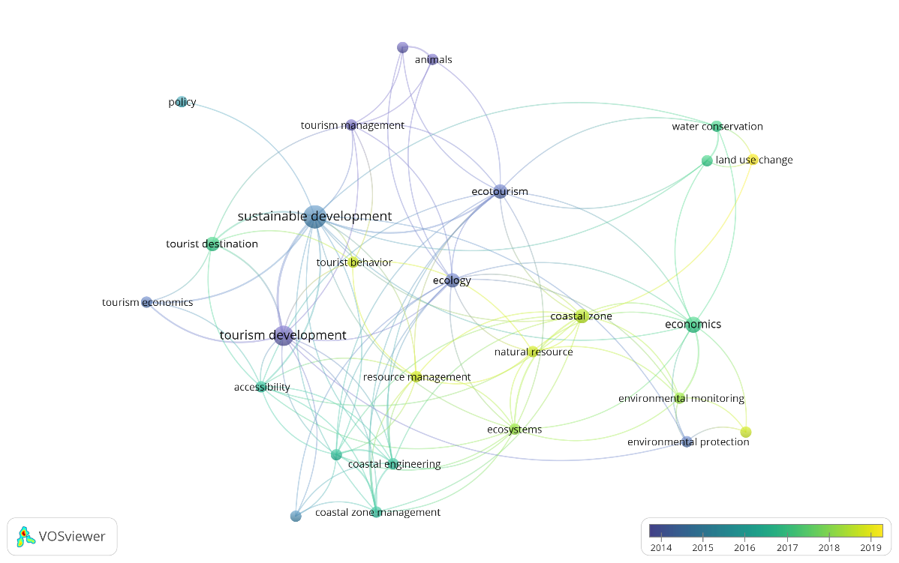
Figure 2. The bibliometric network of keywords

4. Discussion
We identified 46 papers addressing the application of system dynamics on tourism between 2010-2019 (Fig. 3). We found the main topics of system dynamics models: seaside tourism, sustainable tourism, low-carbon economies, destination management, decision making, planning, negative impacts of tourism and tourism in general (some papers might belong to several categories) (Fig. 4). The main implementation platforms were Vensim, Powersim and Stella (see Fig. 5).
Typically, a combination of CLD and SFD was used (23 papers, 50%), followed using SFD only (10 papers, 22%) and CLD only (11 papers, cases 24%). Systems archetypes in combination with CLD rarely appeared (2 papers, 4%).
The temporal scale of scenarios varies from 8 to 110 years; most of the models work with the about 30-year horizon (Fig. 6). In 16 papers, the temporal scale was not specified.
The results of the quantitative synthesis indicate the shift in the scope: while early papers were focused on the impact of tourism on economics and tourist attraction, in later papers sustainability and investment in touristic areas were explored. The interest in coastal zones tourism is significant.

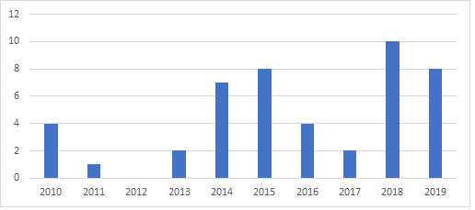
Figure 3. Number of publications per year
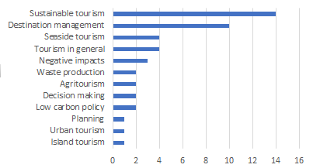
Figure 4. Number of publications per domain
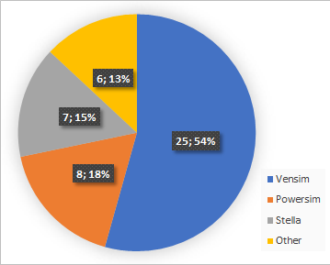
Figure 5. Implementation platforms
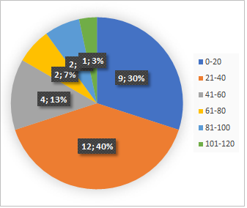
Figure 6. Temporal scale (range of years in simulation)

5. Conclusions
Our systematic review shows the potential of system dynamics models for decision making and planning in tourism, finding externalities caused by tourism, and predicting positive and negative impacts of tourism. Our further research may lead to the development of general system dynamics models of sustainable tourism in protected areas. Another direction of future research might lead to the application of system dynamics modelling in case studies, namely creating models for future policy makings/decision making in order to change the extent of tourism in certain destinations.
Acknowledgments: The financial support of the Specific Research Project Information and Knowledge Management and Cognitive Science in Tourism II of FIM UHK is gratefully acknowledged.

References
Alcalá, F. J., Martínez-Valderrama, J., Robles-Marín, P., Guerrera, F., Martín-Martín, M., Raffaelli, G., et al. (2015). A hydrological–economic model for sustainable groundwater use in sparse-data drylands: Application to the Amtoudi Oasis in southern Morocco, northern Sahara. Science of The Total Environment, 537, 309–322. https://doi.org/10.1016/j.scitotenv.2015.07.062
Aliani, H., Kafaky, S. B., Monavari, S. M., & Dourani, K. (2018). Modeling and prediction of future ecotourism conditions applying system dynamics. Environmental Monitoring and Assessment, 190(12). https://doi.org/10.1007/s10661-018-7078-4
Asasuppakit, P., & Thiengburanathum, P. (2014). System Dynamics Framework for Sustainable Infrastructure Evaluation: Chiang Mai City and Impacts from Tourism, 8.
Beaver, A. (2002). A Dictionary of Travel and Tourism Terminology. Wallingford: CAB International. p. 313. ISBN 978-0-85199-582-3.
Bempah, I. (2018). Dynamics Analysis Model of Nature Tourism System Development In Bogani Nani Wartabone National Park of Gorontalo Province. Jurnal Manajemen, 22(2), 251. https://doi.org/10.24912/jm.v22i2.362
Brennan, C., Ashley, M., & Molloy, O. (2019). A System Dynamics Approach to Increasing Ocean Literacy. Frontiers in Marine Science, 6. https://doi.org/10.3389/fmars.2019.00360
Cheng, L., Sun, H., Zhang, Y., & Zhen, S. (2019). Spatial structure optimization of mountainous abandoned mine land reuse based on system dynamics model and CLUE-S model. International Journal of Coal Science & Technology, 6(1), 113–126. https://doi.org/10.1007/s40789-019-0241-x
Chiu, C.-C., Château, P.-A., Lin, H.-J., & Chang, Y.-C. (2019). Modeling the impacts of coastal land use changes on regional carbon balance in the Chiku coastal zone, Taiwan. Land Use Policy, 87, 104079. https://doi.org/10.1016/j.landusepol.2019.104079
Estay-Ossandon, C., & Mena-Nieto, A. (2018). Modelling the driving forces of the municipal solid waste generation in touristic islands. A case study of the Balearic Islands (2000–2030). Waste Management, 75, 70–81. https://doi.org/10.1016/j.wasman.2017.12.029
Forrester, J.W. (1961). Industrial Dynamics. Pegasus Communications.
Forrester, J.W. (1969). Urban Dynamics. Pegasus Communications.
Halioui, S., & Schmidt, M. (2016). TOWARDS A HOLISTIC ANALYSIS OF TOURISM SECTOR IN TUNISIA: A
Haraldsson, H., & Ólafsdóttir, R. (2018). Evolution of Tourism in Natural Destinations and Dynamic Sustainable Thresholds over Time. Sustainability, 10(12), 4788. https://doi.org/10.3390/su10124788
Hsiao, T. Y., & Hsu, Y. Y. (2014). Modeling Different Scenarios for Forecasting Human Resources Requirements in Taiwan’s Recreational Farms. International Journal of Business Administration, 5(6). https://doi.org/10.5430/ijba.v5n6p1
Jere Jakulin, T. (2016). System dynamics models as decision-making tools in agritourism. Agricultura, 13(1–2), 5–10. https://doi.org/10.1515/agricultura-2017-0002
Jiang, J., Li, J., & Xu, H. (2010). System Dynamics Model for Transportation Infrastructure Investment and Cultural
Kapmeier, F., & Gonçalves, P. (2018). Wasted paradise? Policies for Small Island States to manage tourism-driven growth while controlling waste generation: the case of the Maldives: F. Kapmeier and P. Gonçalves: Managing tourism-driven growth and waste generation. System Dynamics Review, 34(1–2), 172–221. https://doi.org/10.1002/sdr.1607
Koenigstein, S., Ruth, M., & Gößling-Reisemann, S. (2016). Stakeholder-Informed Ecosystem Modeling of Ocean Warming and Acidification Impacts in the Barents Sea Region. Frontiers in Marine Science, 3. https://doi.org/10.3389/fmars.2016.00093
Lee, M. T., & Lin, T. F. (2014). Developing an Interactive Decision Support System for Sustainable Coastal Tourism of Cijin, Taiwan. In 2014 International Symposium on Computer, Consumer and Control (pp. 682–685). Presented at the 2014 International Symposium on Computer, Consumer and Control (IS3C), Taichung, Taiwan: IEEE. https://doi.org/10.1109/IS3C.2014.182
Li, J., Zhang, W., Xu, H., & Jiang, J. (2015). Dynamic Competition and Cooperation of Road Infrastructure Investment of Multiple Tourism Destinations: A Case Study of Xidi and Hongcun World Cultural Heritage. Discrete Dynamics in Nature and Society, 2015, 1–10. https://doi.org/10.1155/2015/962028
Liao, Z., Jin, M., Ren, P., & Luo, Y. (2014). Research on Scenic Spot’s Sustainable Development Based on a SD Model: A Case Study of the Jiuzhai Valley. Sustainability, 6(7), 4632–4644. https://doi.org/10.3390/su6074632
Lu, X., Yao, S., Fu, G., Lv, X., & Mao, Y. (2019). Dynamic simulation test of a model of ecological system security for a coastal tourist city. Journal of Destination Marketing & Management, 13, 73–82. https://doi.org/10.1016/j.jdmm.2019.05.004
Luo, Y., Jin, M., Ren, P., Liao, Z., & Zhu, Z. (2014). Simulation and Prediction of Decarbonated Development in Tourist Attractions Associated with Low-carbon Economy. Sustainability, 6(4), 2320–2337. https://doi.org/10.3390/su6042320
Matthew, G. Jr., Nuttall, W. J., Mestel, B., & Dooley, L. S. (2017). A dynamic simulation of low-carbon policy influences on endogenous electricity demand in an isolated island system. Energy Policy, 109, 121–131. https://doi.org/10.1016/j.enpol.2017.06.060
McGrath, G. M. (2010). Towards Improved Event Evaluation and Decision Support: A Systems-Based Tool. In 2010 43rd Hawaii International Conference on System Sciences (pp. 1–10). Presented at the 2010 43rd Hawaii International Conference on System Sciences, Honolulu, Hawaii, USA: IEEE. https://doi.org/10.1109/HICSS.2010.486
McGrath*, G. M., Law, A., & DeLacy, T. (2015). Green economy planning in tourism destinations: An integrated, multi-method decision support aid. The Journal of Developing Areas, 49(6), 145–155. https://doi.org/10.1353/jda.2015.0093
Mona, S. (2018). A system dynamics approach to study the behavior of Cape Town tourism for the next coming 10 years. South Africa, 5.
Nguyen, N. C., & Bosch, O. J. H. (2013). A Systems Thinking Approach to identify Leverage Points for Sustainability: A Case Study in the Cat Ba Biosphere Reserve, Vietnam: Using Systems Thinking to Identify Leverage Points for Sustainability. Systems Research and Behavioral Science, 30(2), 104–115. https://doi.org/10.1002/sres.2145
Novani, S., Azis, Y., Aprianingsih, A., Aru, A. P., & Putro, U. S. (2019). Collaboration improvement among batik tourism stakeholders of Surakarta City: a value co-creation process with soft system dynamics methodology, 28.
Nugroho, S., Uehara, T., & Herwangi, Y. (2019). Interpreting Daly’s Sustainability Criteria for Assessing the Sustainability of Marine Protected Areas: A System Dynamics Approach. Sustainability, 11(17), 4609. https://doi.org/10.3390/su11174609
Phan, T. D., Nguyen, N. C., Bosch, O. J. H., Nguyen, T. V., Le, T. T., & Tran, H. T. (2016). A Systemic Approach to Understand the Conservation Status and Viability of the Critically Endangered Cat Ba Langur: Conservation status of the Critically Endangered Cat Ba Langur. Systems Research and Behavioral Science, 33(6), 742–752. https://doi.org/10.1002/sres.2387
Provenzano, D. (2015). A Dynamic Analysis of Tourism Determinants in Sicily. Tourism Economics, 21(3), 441–454. https://doi.org/10.5367/te.2015.0480
Ran, W. (2015). A System Dynamics Approach to Exploring Sustainable Tourism Development, 30.
Ropret, M., Jere Jakulin, T., & Likar, B. (2014). The systems approach to the improvement of innovation in Slovenian tourism. Kybernetes, 43(3/4), 427–444. https://doi.org/10.1108/K-07-2013-0154
Sampedro, C., Pizzitutti, F., Quiroga, D., Walsh, S. J., & Mena, C. F. (2018). Food supply system dynamics in the Galapagos Islands: agriculture, livestock and imports. Renewable Agriculture and Food Systems, 1–15. https://doi.org/10.1017/S1742170518000534
Semeniuk, C. A. D., Haider, W., Cooper, A., & Rothley, K. D. (2010). A linked model of animal ecology and human behavior for the management of wildlife tourism. Ecological Modelling, 221(22), 2699–2713. https://doi.org/10.1016/j.ecolmodel.2010.07.018
Shen, Y. (2019). System Dynamics Model of Long Island Marine Stone Forest Park Based on Recreational Opportunity Spectrum. Journal of Coastal Research, 94(sp1), 648. https://doi.org/10.2112/SI94-129.1
Soufivand, M., Alessi, M., & Bivona, E. (2013). A System Dynamics Approach to Enhance Tourism Service Delivery Performance through Value Co-Creation, 25.
Tan, W.-J., Yang, C.-F., Château, P.-A., Lee, M.-T., & Chang, Y.-C. (2018). Integrated coastal-zone management for sustainable tourism using a decision support system based on system dynamics: A case study of Cijin, Kaohsiung, Taiwan. Ocean & Coastal Management, 153, 131–139. https://doi.org/10.1016/j.ocecoaman.2017.12.012
Tegegne, W. A., Moyle, B. D., & Becken, S. (2018). A qualitative system dynamics approach to understanding destination image. Journal of Destination Marketing & Management, 8, 14–22. https://doi.org/10.1016/j.jdmm.2016.09.001
Vugteveen, P., Rouwette, E., Stouten, H., van Katwijk, M. M., & Hanssen, L. (2015). Developing social-ecological system indicators using group model building. Ocean & Coastal Management, 109, 29–39. https://doi.org/10.1016/j.ocecoaman.2015.02.011
Walsh, S. J., & Mena, C. F. (2014). Examining Threats to Iconic National Parks through Modeling Global Change, Biocomplexity, and Human Dynamics, 14.
Widhianthini, W. (2017). A Dynamic Model for Sustainable Tourism Village Planning Based on Local Institutions. Journal of Regional and City Planning, 28(1), 1. https://doi.org/10.5614/jrcp.2017.28.1.1
Xing, Y., & Dangerfield, B. (2011). Modelling the sustainability of mass tourism in island tourist economies. Journal of the Operational Research Society, 62(9), 1742–1752. https://doi.org/10.1057/jors.2010.77
Yin, J., Zheng, X., & Tsaur, R.-C. (2019). Occurrence mechanism and coping paths of accidents of highly aggregated tourist crowds based on system dynamics. PLOS ONE, 14(9), e0222389. https://doi.org/10.1371/journal.pone.0222389
You, S., Kim, M., Lee, J., & Chon, J. (2018). Coastal landscape planning for improving the value of ecosystem services in coastal areas: Using system dynamics model. Environmental Pollution, 242, 2040–2050. https://doi.org/10.1016/j.envpol.2018.06.082
Zhang, J., Ji, M., & Zhang, Y. (2015). Tourism sustainability in Tibet – Forward planning using a systems approach. Ecological Indicators, 56, 218–228. https://doi.org/10.1016/j.ecolind.2015.04.006

© 2019 by the authors. Submitted for possible open access publication under the terms and conditions of the Creative Commons Attribution (CC BY) license (http://creativecommons.org/licenses/by/4.0/).

