Video-conferencing and Virtual Worlds in Language Education – Practical Evaluation of the Systematic Approach in the Czech Context
First Author¹ (name omitted for blind review)
¹ The University, Address
email@xxxx.com
Abstract. A systematic approach is necessary when planning, creating and delivering technology-enhanced ESL courses, while keeping in mind the costs and ever-increasing expectations of learners. The systematic approach proposed by Moore and Kearsley has been practically evaluated in several EFL courses for both elementary students and adult learners. The blended courses made use of technologies such as video conferencing or virtual worlds in various combinations with face-to-face teaching. Lessons learned regarding the applicability and usefulness of the evaluated forms and methods are presented. Communication with native speakers via video-conference has proven its potential in increasing elementary students’ language confidence and their interest in language learning; students’ reflection was generally positive and the method appeared suitable for grades 4 and 5 with very little initial language knowledge. Adult learners' reactions were also positive, appreciating the well-known benefits such as increased flexibility and saved time. In addition to the overall positive reception, trials revealed both technical and psychological weaknesses and challenges connected with the methods and their specific combinations. The research is presented in the wider context of Czech language schools offering video-conference-based courses. The study of changes in courses offered by several language schools between 2014 and 2019 provides an additional glimpse of the evolution of the adoption and perception of relevant technologies, further supporting the necessity of a systematic approach.

Keywords: video-conference, virtual worlds, blended learning, EFL
- Introduction
Some of the new challenges facing for course designers, instructors (teachers/tutors), language school management and others involved in the educational process include different cognitive approaches of today's digital citizens [16], the pace of life, traffic congestions in urban areas, high mobility for business and tourism. Quality resources including authentic rich multimedia and relevant software and hardware abound, though their proper exploitation may pose a challenge. Serious attempts to embrace IT in collaborative language education may be traced back to 1992, when Kelm [8] reported how non-native speakers of Portuguese participated in a real-time class facilitated by computer networks. A control group was used to compare participation with the face-to-face setting. The study concluded that computer-assisted discussions promote participation, reduce anxiety, render the expression of emotion, etc. Roed [22], as well as studies referenced by him, confirm that when communicating online, people display less social anxiety, fewer inhibitions, and lower public self-awareness. In result, they tend to be more honest and more forthcoming in telling about themselves and presenting their viewpoints. A virtual learning environment may provide more relaxed experiences than a physical classroom.
However, the online form will likely not replace traditional forms, or at least, not very soon. Lu, Goodale and Guo [13] present an educational collaborative project between two colleges in the United States and China. Online synchronous video-conference-based communication was arranged between future Chinese teachers and American undergraduates for 10 weeks to improve Chinese learners’ English oral skills and their confidence in teaching the English language. It had positive impacts on learners' pronunciation, oral fluency and coherency, though confidence did not improve significantly. The study indicated that face-to-face language instruction by non-native speakers works better for grammar, whereas online video-conference with native English speakers serves as a practical, affordable, effective alternative especially for listening and speaking skills. Combining native and non-native speakers, face-to-face and virtual forms together with extra study seems very promising. More authors are in favour of such blended courses [3, 5, 9].
In the following paragraphs, specific challenges of technology-enhanced course delivery are discussed in Moore and Kearsley's [15] analysis. Language courses offered in the Czech Republic are briefly examined to provide a context. Finally, specific lessons learned from the application of online and blended forms in English language courses are presented.
- Technology-enhanced Courses – the Systematic View
Video-conferencing provides advantages, however, the technology brings additional complexity to the conventional educational model (Fig. 1). Additional and often uncontrollable variables affect the success of the learning process. Disruptions may emerge in the user interface (both hardware and software), in the underlying operating system and network, in the physical environment (sound conditions, light conditions, sources of distraction), or be caused by humans (both learners and instructors).

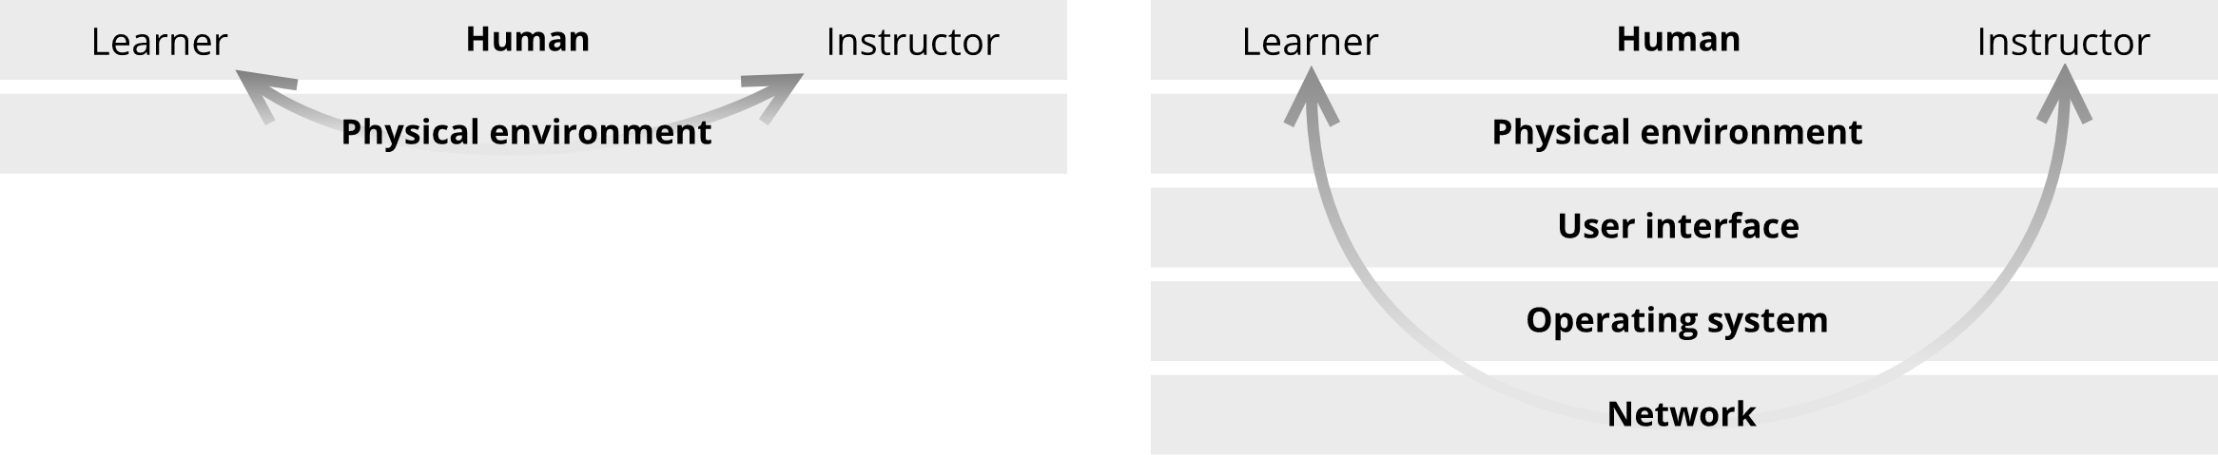
Fig. 1. Increased complexity of technology-enhanced courses. Source: authors
Moore and Kearsley made an effort to deconstruct the process of creating and delivering a broadly defined distant course in order to analyze its internal structure [15]. According to them, distant courses have to be conceived of and developed as a total system, giving sufficient attention to all its components. A systemic view allows for the identification of both inputs, such as learners' characteristics, instructors' experience, learners' access to resources, and outputs, such as satisfaction ratings and quality assessments, achievement scores, completion rates, total enrollments, costs and revenue, and for the analysis of how they interact and influence each other (Fig. 2).
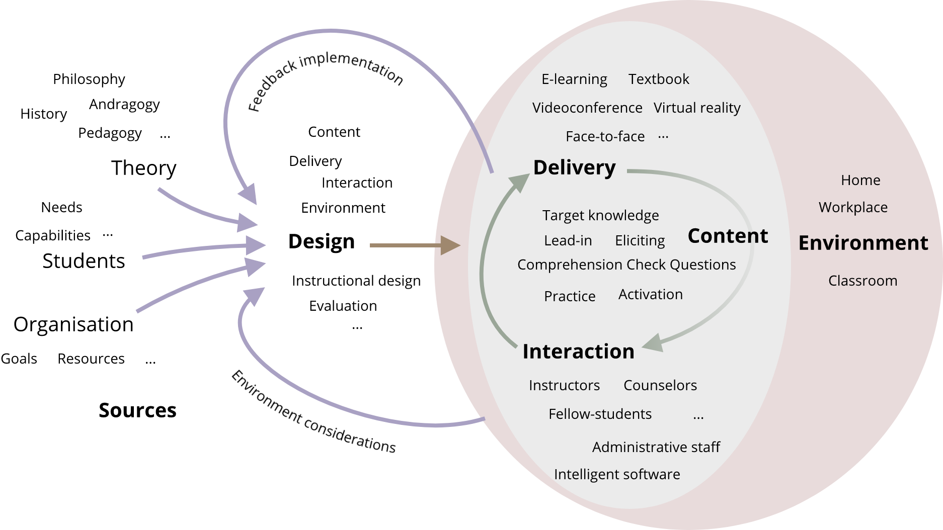
Fig. 2. Course life-cycle within its environment, including the design, creation, delivery, interaction, and implementation of the feedback. Source: authors, inspired by [15]
  - The Design Stage

The design stage requires individuals with knowledge of instructional principles and techniques as well as knowledge of the technology. As Moore and Kearsley [15] mention, designers are not necessarily good instructors and vice versa. So, the expertise of pedagogues, content authors, instructional designers, IT and digital media specialists has to be combined, depending on the course purpose and target group.
For example, poor design-stage decisions negatively affected attendance and overall success of Health Services Management's video-conference-based courses held at the University of South Africa [14]. Participants were happy about the clarity of the course content and feedback on assignments, however, the lecturers were reportedly hasty to finish the content within the allocated time. The implication is clear – course designers should find the appropriate amount of material should they include in each lesson. Expectations based on experiences with face-to-face courses may be too high; the amount of information which may be successfully delivered via video conference may be significantly lower for a variety of reasons (worse transmission of non-verbal signs, voice quality, the time required to set up the environment and to solve technical issues, etc.). Good communication between course designers and other relevant experts in the design stage and proper testing is necessary to minimize the drawbacks and risks.
Educational videoconferencing systems should foster natural interaction between the learner and the instructor, thus supporting both psycholinguistic and the sociocultural knowledge acquisition. Hampel and Stickler [4] analyzed written and spoken interaction in recorded video-conferencing sessions and additional quantitative data to find out how learners use and combine multiple modes to make meaning. Deeper insights into learners' cognition may help to design better multi-modal educational systems and better courses.

  - Delivery and Interaction Stages

In the delivery and interaction stages, sufficient interaction with instructors is a must [15], though the nature and extent of the interaction may vary according to circumstances, such as organizational and designer's teaching philosophy, the nature of the subject, technical matters, skills and maturity of learners, location of all involved parties and available media. Course structure may consist of smaller functional blocks of activities, switching between explanation and interactive practice rather than putting a sharp distinction between the delivery and interaction. Vertical interaction between instructors and learners as well as horizontal interaction between learners is useful. Wu [30] in the study concerning EFL instructional models examined how focused peer interaction contributes the learners. Learners in Taiwan interacted with a native English speaker in America with peer interaction involved. Integrative and instrumental motivation, satisfaction, confidence, and actual performance improved as a result of peer interaction.
The importance of the instructor's competence in handling technology as a part of the educational process is examined in the case study conducted with an EFL teacher at a German secondary school [23]. Though the study is concerned with the interactive whiteboard, it provides a good parallel for the effective delivery of a video-conference-based course. The competencies concluded as necessary are (1) the ability to design relevant materials, (2) the appropriate management of interaction around the equipment in a way that ensures all learners are provided with opportunities to be actively involved, and (3) the ability to find the ‘right balance’ of technology use. Bigger responsibility lies with learners too. They have to consciously acquire the skills and habits of being effective distant learners [15]. It may involve adjustments to their schedule, to the software and hardware, the physical environment, and securing cooperation from the family, co-workers, etc.
- Video-conference-based Courses in The Czech Context
Several Czech language schools advertise video-conference-based courses. Kohoutová [10] in 2014 described the form as comfortable, effortless, economical (no need to travel – time and money saved), and flexible regarding the schedule and course contents. Video-conference-based courses were offered for a lower cost to reflect the savings in running costs on their side. The school use their own lesson plans, so learners didn't need printed textbooks. All activities, such as listening, writing, reading, with high emphasis on conversation were included. Learners could keep recordings of all sessions for their future reference. As of 2019, the presentation of the school is no longer online, most likely because the school suspended its operation.
The course offerings of POLYGLOT jazyková škola s.r.o in 2014 [20] was almost the same as is in 2019 [21]. They advertise their Skype-based courses as an alternative to the face-to-face suitable mainly for those who can't attend in person for whatever reason. The main advantages are indicated by words such as modern, efficient, comfortable, any time and accessible from anywhere. Also, the tutor is not fixed to the physical classroom, which brings additional flexibility – tutors from around the world may be employed seamlessly. Sessions are recorded for learners' personal reference and also as a proof of attendance and active participation. Both conversational and textbook-based courses are offered, mainly for individual one-to-one sessions, but small groups up to three learners are also supported.
SPĚVÁČEK jazyková škola s.r.o. [25] in 2014 highlighted time flexibility and accessibility from anywhere. Skype-based courses were recommended as a great supplement to face-to-face courses. Besides the real-time communication with the tutor, their courses offered further content, such as additional audio, multimedia, and writing exercises. As of 2019 [24], the school specifically advertises blended learning as a form suitable mainly for corporate language courses. They off a combination of forms such as e-learning, video-conference either via Skype or other means. The tutor either conducts normal lessons according to a course plan or provides individual consultations tailored to learners' specific needs. Asynchronous means of electronic communication are used as well e.g. to facilitate homework workflow.
The offerings of WANGLE SCHOOL s.r.o. in 2014 [28] was almost the same as in 2019 [29]. They offer video-conference-based language courses both one-to-one and for groups of up to five learners. The courses are offered to all who prefer home setting, from busy managers to mothers busy with children. A web-based video-conferencing system provides screen-sharing and file-sharing functions.
Lampa systems s.r.o. [12] provided a matching directory of tutors who were available for individual online lessons. Besides languages, music lessons and formal and natural sciences were offered as well. Among the main advantages they mentioned were schedule flexibility, accessibility from anywhere and increased comfort. The school deployed their own web-conferencing system integrated into a course-planning and management application. Content created specifically for the video-conference-based courses was used by the tutors. Sessions and materials were monitored to oversee their quality. The application provided further means of interaction, such as text message exchange and sending files. The product most closely harmonized with the systematic approach suggested by Moore and Kearsley [15] among those examined in 2014. While in 2014 the conferencing room provided only very basic functions even in comparison with Skype, by 2019, it evolved and eventually matured into a product gaining more popularity, with almost 97 thousand lessons taught so far according to its website [11].
Videoconferencing and blended learning models are penetrating the mainstream language education at a rather slow pace. Some traditional language schools offer video-conference as an extension or an alternative to face-to-face courses, but often not systematically enough [15]. Budget limitations, perceived risks of the investment, technical problems, insufficient tutors' capabilities, or learners' preference of face-to-face form might have contributed to the results. Skype seems to be the tool predominantly used, despite its limitations (limitation on the number of participants, obtrusive advertisements, limited media sharing, the absence of API since 2013). The case of Lampa systems s.r.o. illustrates the good results of a persistent thorough systematic approach in technology-enhanced course creation and delivery.
- Video-conferencing and Virtual Worlds for EFL Courses
To evaluate practical applicability of video conferencing and blended-learning approaches in ESL education of different target groups, two projects were conducted in two regions of the Czech Republic between 2011 and 2015 with the support from the Education for Competitiveness programme co-funded by the EU.

  - Connecting Foreign Tutors with Students at Elementary Schools

The first project aimed at the students of six elementary schools in the Hradec Králové region and was conducted between November 2011 and December 2012. Specifically designed video conferencing sessions were experimentally blended with the ordinary English language lessons taught at the participating schools. With the general goals of elementary education in mind [27], including acquisition of effective learning, motivation for life-long education, supporting creativity, effective communication, respect for others, cultural and moral values, specific areas of benefits for students were determined and followed as goals: (1) the language confidence, (2) the ability to work in teams, (3) the ability to combine knowledge from different subjects, (4) the ICT literacy, and (5) respect for differences in the multicultural world. Three specific courses have been created for grades 4 and 5, 6 and 7, 8 and 9 respectively, consisting of lesson plans, instructions for tutors, and supplementary materials. Up to four tutors connected in parallel in one classroom with a teacher physically present to oversee; each tutor was assigned to a team of 4 – 5 students. Tutors from the Philippines were hired to make the activities more appealing for the students. Skype was used predominantly for interaction. A custom course management information system has been developed for timetable planning, progress management, feedback gathering and work reporting.
Eventually, 547 students participated; feedback questionnaires were collected from 433 students and from 119 parents. The data supported what has been observed throughout the project – the activities were perceived as interesting, inspiring, and beneficial for the students. During the preparation and at the beginning of the project there were some doubts about the applicability of the method in lower grades. But the data collected has shown, that lower grade students were even more positive about the method and their perception of an increase in the language confidence and at least similarly positive in other aspects. For more details refer to [31].
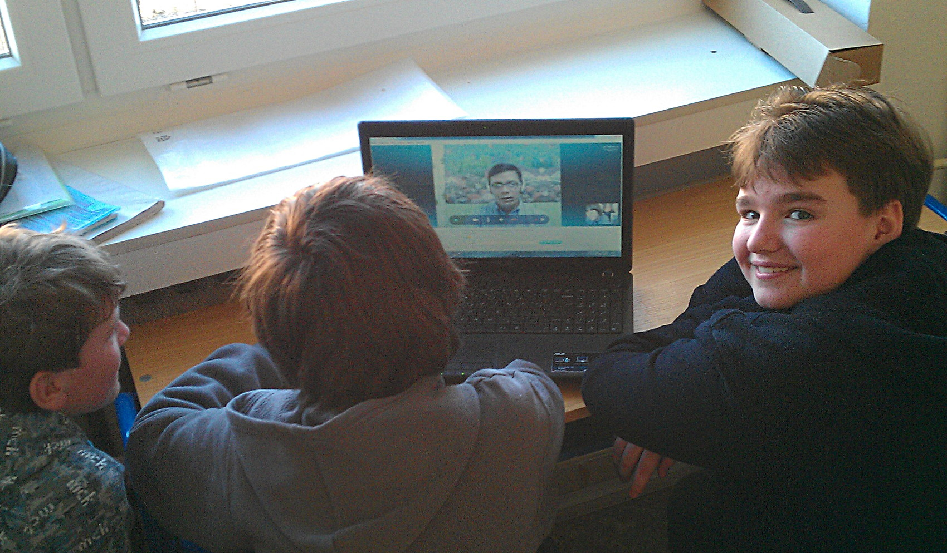
Fig. 3. Students talking to a Filipino tutor. Source: authors
  - Video-conferencing and Virtual Worlds in Courses for Adult Learners

The two other projects aimed at adult ESL learners mainly from the Hradec Králové and Zlín regions of the Czech Republic. The goal was to evaluate various forms of online or blended education, with various specific target groups on mind, such as (1) learners with physical disabilities, (2) mothers on maternity leave or more generally parents on parental leave, (3) the elderly, (4) very busy persons, such as managers, (5) IT enthusiasts. Experimental information systems were developed to support or facilitate the learning process, specific courses were prepared, tutors trained. The courses, methods and the technology were eventually evaluated on 461 participants.
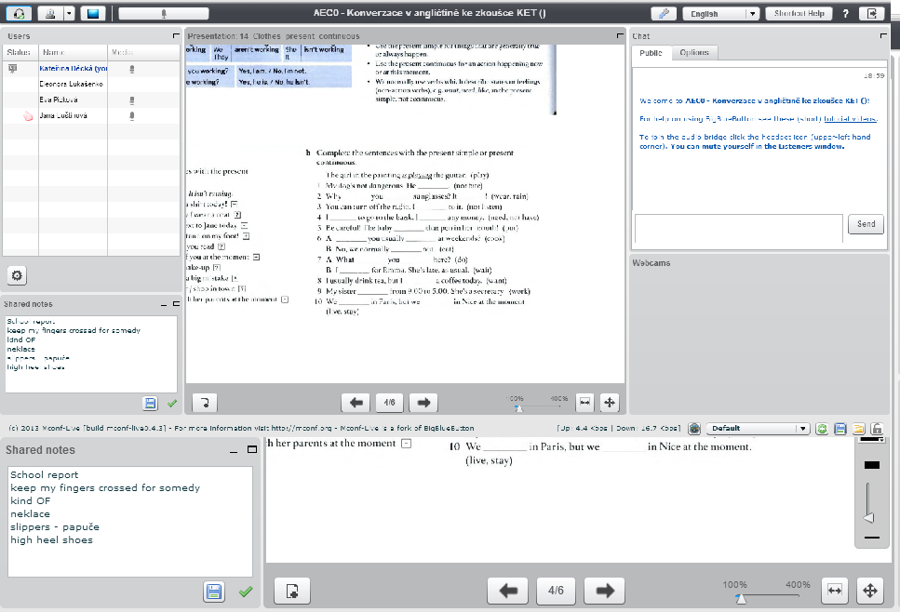
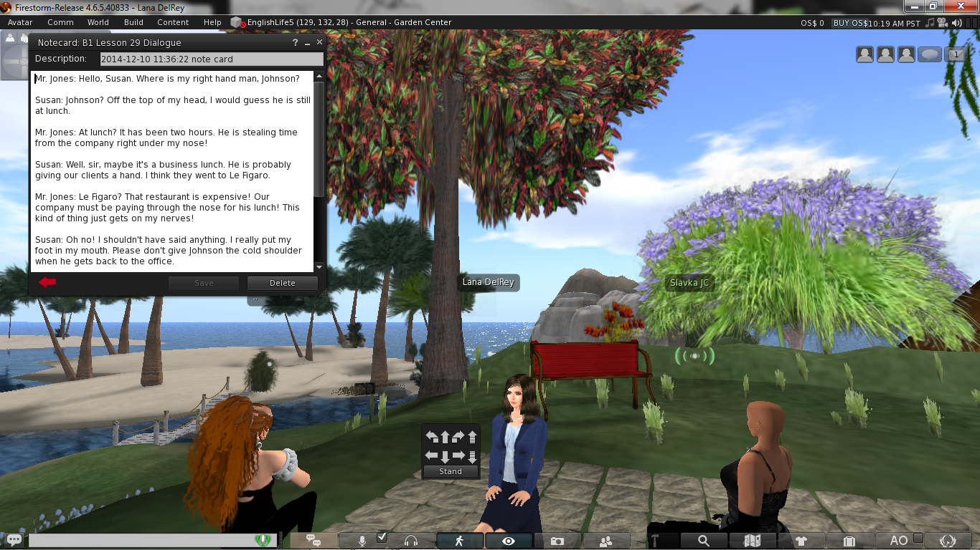
Fig. 4. Sample virtual world and video conferencing room screens. Source: authors
Three ESL courses have been prepared for virtual worlds running on the OpenSimulator [18] technology, namely for OSGrid [19] and Metropolis Metaversum [6] worlds. As a base in each world, custom regions have been deployed, but tutors were instructed by the courses to take their learners to various locations according to the character and objective of each session. An integration bridge has been implemented between the OpenSimulator instance and course management system for the purposes of attendance records, user management, course and schedule management, feedback, an overview of learners progress, etc.
A variety of ESL courses have been prepared for video conferencing or for blended courses. A web-based course management system has been developed [17] with per-institution domain separation, attendance tracking and configurable layouts. The system was built upon the web2py application framework [2]. BigBlueButton open-source video-conferencing client-server system [1], deployed within the international high availability video-conferencing network Mconf [26], was integrated into the system to provide multi-way video connections, session recording and in-session content sharing. Classrooms were equipped with a comprehensive sound system, camera and a big screen to allow remote learners to connect directly and participate fully on face-to-face sessions (Fig. 5).
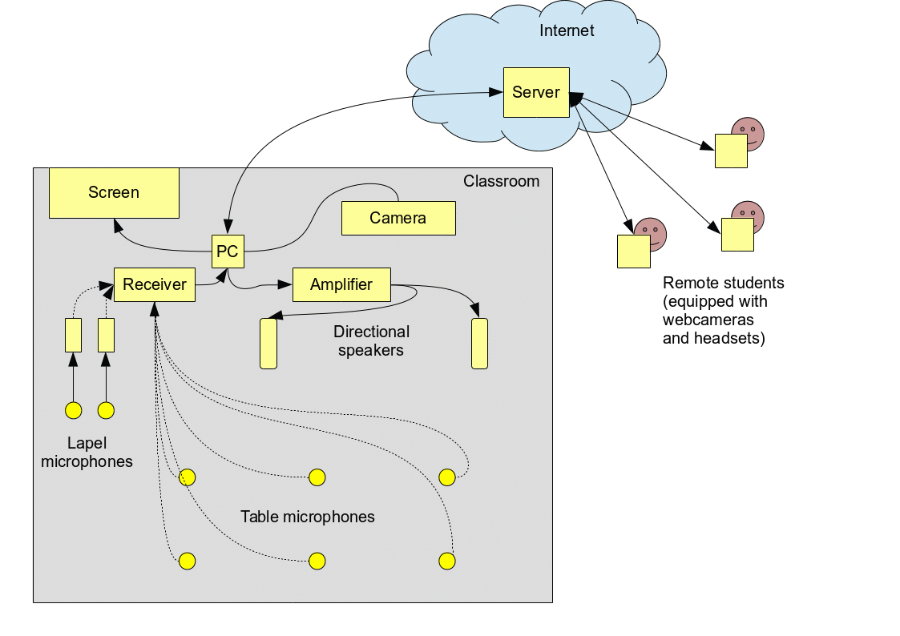
Fig. 5. Equipment in the classroom for the full participation of remote learners. Source: authors
Because BigBlueButton did not support shared video playback during the session a solution based on WebcamStudio [7], involving a virtual camera and virtual microphone fed by a video-stream was tested successfully. Fig. 6 illustrates the flow of video and audio signal through the WebcamStudio to the BigBlueButton.
Though the learners' feedback throughout the courses was positive, weaknesses and limitations of the methods and tools were observed too. Courses in virtual worlds required substantial technical support for the participants, especially when incompatibilities arose. Several less patient learners or those with less adequate hardware were even deterred from continuing their participation. The camera made some learners feel anxious about their appearance; table microphones and the camera in the classroom seemed to have an even stronger negative impact on the learners' anxiety. The lack of previous experience with video conferencing or with a table microphone among some learners probably played a role.
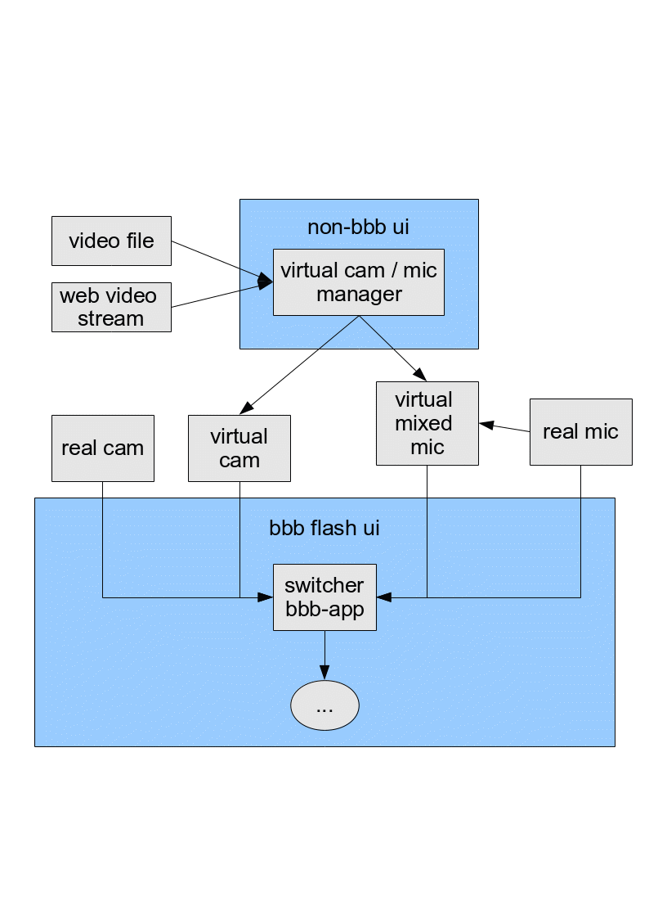Fig. 6. Video playback implemented by the means of a virtual camera and a virtual microphone
On the contrary, the courses conducted in a virtual world made learners feel less anxious about their language. However, handling the complex English user interface of the virtual world viewer, navigating the avatar and performing other actions was a challenge for some. The interface should be simplified, or even radically stripped down. Also connectivity problems affected the course delivery at times.
- Conclusions
Involving technology, such as video-conferencing and virtual worlds, makes courses more accessible or appealing, but the increased complexity leads to new challenges and potential problems. As suggested by Moore and Kearsley [15], courses should be created and delivered in a systematic way. It should start with the course planning and creation, based on thorough analysis of learners' needs and capabilities, organizational goals and resources and the technical aspects. Implications of various studies relevant to the course delivery and interaction were discussed. The technology should not distract the attention and divert the focus from humans, learners in particular. Learners should not be distracted by unnecessarily complicated user interfaces; distractions or even disruptions caused by technical problems should be minimized. Training of instructors, thorough testing, systematic feedback collection and implementation, all these are necessary. Schools which offer video-conference-based courses usually highlight advantages such as comfort, flexibility, or affordability. The comparison of how several Czech language schools presented their usage of video-conferencing in 2014 and in 2019 respectively harmonize with the importance of the systematic approach in the course creation and delivery. Whereas schools which offered the video-conference only as an addition to the face-to-face courses did not evolve their embrace of the technology significantly during the period, the one school which paid attention to the all the essential aspects from the beginning has grown into maturity and gained popularity.
Three experimental projects successfully evaluated the applicability of virtual worlds and video conferencing in courses for both elementary school students and adult learners. Elementary students, even from lower grades, may benefit if the technology is used to facilitate communication with native speakers, boosting students' language confidence and interest in learning the language, besides other positive effects. Regarding adult learners, various groups of people could benefit from the IT-supported distant or blended learning, such as those with physical disabilities, those limited by their time-consuming family responsibilities, the elderly, business people busy with work or travelling extensively both for business and tourism reasons, or IT enthusiasts. Various forms were evaluated, such as purely online courses conducted either via video-conference or in an online virtual world, courses combining online and face-to-face sessions, or allowing remote participation on face-to-face courses in a classroom. The systematic approach to the course creation and delivery contributed to the positive response. However, various technical and psychological challenges require further attention.

The financial support of the Specific Research Project “Information and knowledge management and cognitive science in tourism 2” of FIM UHK is gratefully acknowledged.

References

1. Blindside Networks: BigBluebutton - project website, http://bigbluebutton.org/.
2. Di Pierro, M.: Web2py Web Framework - project website, http://web2py.com/.
3. Garrison, D.R., Kanuka, H.: Blended learning: Uncovering its transformative potential in higher education. The Internet and Higher Education. 7, 2, 95–105 (2004).
4. Hampel, R., Stickler, U.: The use of videoconferencing to support multimodal interaction in an online language classroom. ReCALL. 24, 02, 116–137 (2012).
5. Hubackova, S. et al.: Blended Learning In A Foreign Language Teaching. Procedia - Social and Behavioral Sciences. 28, 281–285 (2011).
6. Hypergrid.org: Metropolis website, https://hypergrid.org/metropolis/wiki/en/index.php?title=Hauptseite.
7. karl-ellis et al.: WebcamStudio For GNU/Linux, https://sourceforge.net/projects/webcamstudio/.
8. Kelm, O.R.: The Use of Synchronous Computer Networks in Second Language Instruction: A Preliminary Report. Foreign Language Annals. 25, 5, 441–454 (1992).
9. Kissau, S.: Perceptions of self-efficacy for two types of second language methods instruction. Computer Assisted Language Learning. 25, 4, 295–317 (2012).
10. Kohoutová, K.: Individuální výuka angličtiny přes videokonference skype, http://www.jazykova-skola-online.cz/individualni-vyuka-anglictiny-a-nemciny-pres-skype.php.
11. LAMPA Systems s.r.o.: LAMPA - Lesson & Activity Management, Planning & Access, https://www.mylampa.com/.
12. LAMPA Systems s.r.o.: LAMPA - Learning and teaching on-line, http://www.mylampa.org/.
13. Lu, R. et al.: Impact of Videoconference with Native English Speakers on Chinese EFL Learners’ Oral Competence and Self-Confidence. Open Journal of Social Sciences. 02, 02, 54–60 (2014).
14. Matlakala, M.C. et al.: Video conference teaching at an Open Distance Learning (ODL) university in South Africa: Analysis of benefits and drawbacks. African Journal for Physical Health Education, Recreation and Dance: The transitional phase of pedagogy in higher education: Supplement 2. 19, 22–31 (2013).
15. Moore, M.G., Kearsley, G.: Distance Education: A Systems View. Wadsworth Publishing, Belmont, CA (2004).
16. Mossberger, K. et al.: Digital Citizenship: The Internet, Society, and Participation. The MIT Press, Bellingham, Wash (2007).
17. Open-IT cz, s.r.o.: lightClass - project website, http://lc.o-it.info/.
18. OpenSimulator: OpenSimulator website, http://opensimulator.org/wiki/Main_Page.
19. Osgrid Inc.: Osgrid website, https://www.osgrid.org/.
20. POLYGLOT jazyková škola s.r.o.: Polyglot.cz - Skype kurzy, http://www.polyglot.cz/jazykova-skola-POLYGLOT/1086-skype-kurzy/.
21. POLYGLOT jazyková škola s.r.o.: Polyglot.cz - Skype kurzy, https://www.polyglot.cz/cs/jazykova-skola/skype-kurzy/.
22. Roed, J.: Language Learner Behaviour in a Virtual Environment. Computer Assisted Language Learning. 16, 2–3, 155–172 (2003).
23. Schmid, E.C.: Developing competencies for using the interactive whiteboard to implement communicative language teaching in the English as a Foreign Language classroom. Technology, Pedagogy and Education. 19, 2, 159–172 (2010).
24. SPĚVÁČEK jazyková škola s.r.o.: Spěváček - Blended Learning, https://www.jazykovka.info/firemni-jazykove-kurzy/blended-learning/.
25. SPĚVÁČEK jazyková škola s.r.o.: Spěváček - Skype Learning, http://www.kurzy-spevacek.info/e-learning/skype-learning/.
26. Universidade Federal do Rio Grande do Sul: Mconf - project website, http://mconf.org/m/.
27. Vodáková, J.: Obecné cíle základního vzdělávání, http://www.zkola.cz/zkedu/rodiceaverejnost/vybirameskolu/zakladniskoly/28223.aspx.
28. WANGLE SCHOOL s.r.o.: Wangle School - On–line jazykové lekce, http://www.wangleschool.cz/on-line-jazykove-lekce.
29. WANGLE SCHOOL s.r.o.: Wangle School - On–line jazykové lekce, http://www.wangleschool.cz/on-line-jazykove-lekce.
30. Wu, W.-C.V. et al.: Promotion of EFL Student Motivation, Confidence, and Satisfaction Via a Learning Spiral, Peer-Scaffolding, and CMC: International Journal of Computer-Assisted Language Learning and Teaching. 2, 3, 54–75 (2012).
31. Zejda, D., Canoy, E.: Videoconferencing and Virtual Reality in the Context of Language Education. International Journal for Talent Development and Creativity. 2, 2, 175–186 (2014).

English as a foreign language

