Submitting to a peer-reviewed section – no authors mentioned

**Title of the paper**: Success factors of airlines YouTube videos

Abstract

Social media are changing the way that people consume, share, communicate and create content and thus have an important influence on tourism marketing. This paper aims to find, which factors are increasing the probability of airlines video going viral. The analysis was done for most successful YouTube airline accounts, which were selected by social media analytical software Socialbakers. For factor analyses was used statistical software IBM SPSS Statistics. A correlation was found between the video length and the number of interactions per 1000 subscribers, as well as the optimal length of airline video to get the most user interactions.

**Keywords**: YouTube, Airlines, Success factors, Viral Marketing, Social Media

# Introduction

The Internet and social media changed dramatically all kind of areas; digitalization is the new standard, and the specific business models are in constant evolution. Social media are deeply entrenched in our lives, they reached 82 % of the world’s internet population aged 15+ and represents the largest portion of individuals internet usage, accounting for nearly 1 of every 5 minutes spent online globally (Zhu & Chen, 2015). In keeping with this knowledge, current marketing places increasing emphasis in its practice and gradually in its theory on flexible use of social media (e.g. Ketter, Avraham, 2012). One of the important issues is to increase the marketing effectivity of the social media content (Musa et al., 2016) intentionally generated by organizations, as well as user-generated content, linked to the official accounts of organizations on social media. One measure of this marketing effectiveness may be the degree of virality of the content offered, which is related (in addition to other influences, see mind map in Figure 1) to the nature of the content being offered. The key for successful marketing among social media channels is to create a trust relationship (Wu et al, 2017).

Web 2.0 applications can directly engage consumers in the creative process by both producing and distributing information through collaborative writing, content sharing, social networking, social bookmarking and cooperation (Thackeray et al., 2008), including consumers active incorporation in marketing process (Ketter, Avraham, 2012; in the frame of place marketing). In the context of use in corporate marketing, Facebook and YouTube have a very important position among social media. YouTube, a video-based communication medium, has become one of the most successful ways to express feeling (Safko & Brake, 2010), communicate with friends and advertise business messages (Ketter, Avraham, 2012).

Airlines have sophisticated digital marketing and large airlines are active daily on social media (Zelenka & Hruška, 2018b). The most common are for them Facebook, Twitter, YouTube, and Instagram, but LinkedIn, Google+ and some others are also used (Zelenka & Hruška, 2018b). A big amount of those airlines even posts more than one contribution on Facebook, Twitter, and Instagram a day, on YouTube is that frequency lower. Perhaps this lower frequency usage of YouTube by airlines is the reason why marketing of airlines on YouTube is little studied in the literature. That is why the authors decided to further develop the analysis of various aspects of the use of YouTube by airlines and follow up on their previous publications (Zelenka, Hruška, 2018a, 2018b; Pásková, Hruška & Zelenka, 2018).

# Theoretical basis

By the last years, a number of assumptions appear to have risen up around social media. The growth of social media has brought a series of obvious changes in how marketing is conducted, most importantly, making it interactive (Deighton & Kornfeld, 2009). Social media alone can indeed have a massive impact, when a campaign becomes viral (Macdonald & Wilson, 2012), and are increasingly important for brands communication (Murdough, 2009, cit. in Ashley & Tuten, 2014). It is important to keep in mind that this impact can be huge but in case of social media, it is often also relatively short term (see viral dynamics in France, Vaghefi, & Zhao, 2016) if it is not constantly supported by other company elements and campaigns. Allocca (2011) said that to be viral, three things are helpful:

1. **tastemakers**: many of the famous videos were uploaded even a year before they go viral, but when tastemaker posts it on social media and shows it to the greater audience, it speeds up the process,
2. **participation**; community participates not only by watching the video, but also creating new content from the original video,
3. **total unexpectedness**; it is necessary to create something that nobody expects.

Many studies focused on viral marketing (Wardhana & Pradana 2016, Feroz 2014, Stephen 2016) are describing the critical importance of eWOM and customer recommendation. Wardhana and Pradana (2016) mention customer recommendation as the highest priority. Viral marketing – especially when used as an integrated rather than isolated approach – can both improve brand advocacy and increase mass-market brand awareness, all at an infinitely lower cost than conventional media campaigns (Kirby & Marsden, 2006).

This study will be mainly focused on the “virality and popularity own video factors” area shown in the Figure 1. As the marketing and communication evolve beyond its traditional form, graduate marketing pedagogy must evolve to ensure that those charged with the creation of viral marketing campaigns and the management of consumer-generated advertisements understand the factors influencing the success of both (Handelman, 2006; Berthon, Pitt & Campbell, 2008). The notion of building strong and favourable brand associations is regarded as a highly valuable concept in business practice. Understanding and achieving brand value can result in greater loyalty, additional brand extension opportunities, improved perceptions of product performance, marketing success and sustainable competitive advantage (Keller, 2009). The management of brands is a strategic issue that can affect the firm as a whole (Keller, 1999, Payne et al., 2011). Marketers have several options within the social media landscape for branding, including placing paid display advertising, participating in social networks as a brand persona, developing branded engagement opportunities for customer participation within social networks, and publishing branded content (known as content marketing or social publishing) in social channels (Tuten & Solomon, 2013).

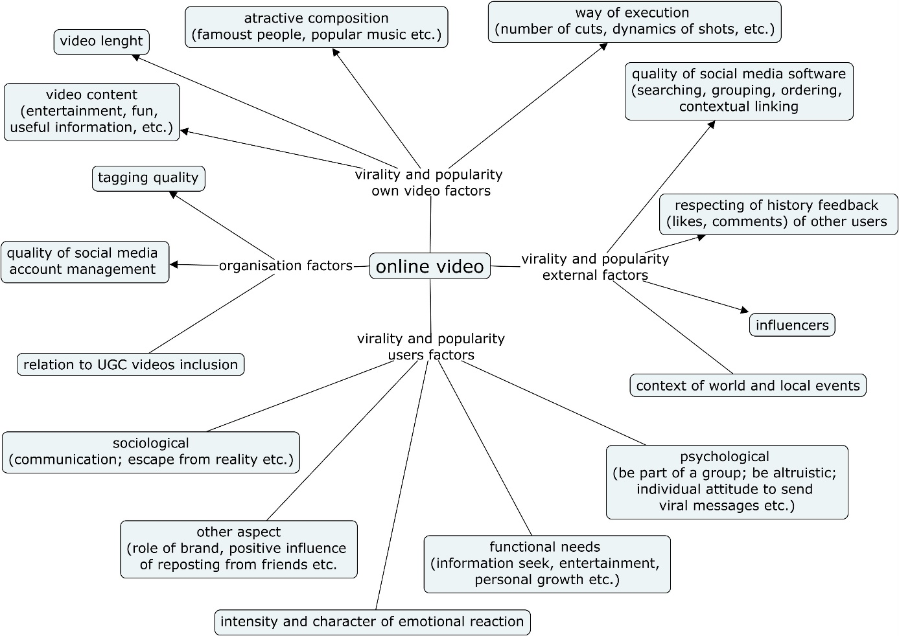

Figure 1 Factors, which influence viral potential and popularity of online videos. Source: own elaboration, based on Wang, Yu and Fesenmaier (2002), Ho and Dempsey (2010), Camarero and San José (2011), Guadagno et al. (2013). Khan and Vong (2014), Ketelaar et al. (2016), Khan (2017), Chen, Chang and Yeh (2017).

# Methods

According to the main research topic, which is virality of airlines videos on YouTube, the following research questions were chosen:

1. What type of videos creates the most interactions in the selected sample?
2. Will people more interact in music or in talkative videos in connection to airline companies?
3. What are optimal settings of videos for the most interactions?

## Study Design

At first were selected most successful YouTube airline accounts by statistical and social media analytical software Socialbakers, which allow analysing YouTube channels or compare them. Socialbakers can display daily, monthly or yearly data of interactions, most successful videos or frequency of uploading new videos. Those airlines were selected by Socialbakers as the top 10 airlines sorted according to the most interactions per 1000 subscribers in one year (from 30.4.2017 to 1.5.2018). Then top five or six most successful videos (with most interactions, that means most comments, shares and likes) of every airline company was selected. Analysed via variables for videos description **Error! Reference source not found.**were thus the sample of 55 videos in period between 30.4.2017 and 1.5.2018. Great attention was paid to the role of music in videos, because, as presented by Liikkanen and Salovaara (2015), music videos are the most popular genre on YouTube. As the results of previous studies (Zelenka, Hruska, 2018a, 2018b) pointed to the importance of video content, their qualitative analysis was performed. Videos were qualitatively typologised into five groups – funny (contains mostly comedy aspects), emotional (expressing strong feelings – sad, regret, lonely, happy), educational, shocking, and others.

## Data Quantitative Analysis

Data and variables for analysis were gathered in different types of statistical and analytical software. Pearson correlation, linear regression and simple mean analysis was processed in statistical software IBM SPSS Statistics. These statistics correlations were computed between variables *total_interactions* (total number of all interactions – to like/ dislike the video, and comment on video), *interactions_per_1k_subs* (number of interactions per 1000 subscribers)*, length_sec* (video length in sec), *title_chars* (number of characters in the video title), *desc_chars* (number of characters in the video description), *desc_links* (number of links in the video description), *tag_count* (a number of tags/ keywords), *music_percent* (amount of video filled with music), and *cut_number* (a number of situations where the camera switched to another screen).

Social medial analytical software Socialbakers was used for measure videos performance (an activity of subscribers, comments on posts, etc.) in time. The second software for gathering data was vidIQ, freeware plugin in Google Chrome browser. In vidIQ was calculated *VidIQ_SEO_Score*, which is a combination of tag count, tag volume, keywords in the title, keywords in the description, tripled keywords (same keyword used in title, description and tags), and ranked tags and high volume ranked tags (both by Google).

# Results

The first step in the analysis was to calculate the mean values of all selected variables for all selected videos on YouTube and record minimum and maximum values (Table 1**Error! Reference source not found.**). These calculated values were used to compare in further analysis of the properties of selected videos on YouTube for different airlines.

Table 1 The average value of the variables for the selected videos on YouTube

|  |  |  |  |
| --- | --- | --- | --- |
| **Variable** | **Mean** | **Minimum** | **Maximum** |
| Interactions_per_1k_subs | 32 | 1,6 | 471 |
| Length_sec [s] | 187 | 7 | 1477 |
| Title_chars | 46 | 12 | 89 |
| Description_chars | 470 | 0 | 1380 |
| Description_links | 3 | 0 | 12 |
| VidIQ_SEO_score | 24 | 0 | 69 |
| Tag_count | 14 | 0 | 47 |
| Music_percent | 52 | 0 | 100 |
| Cut_number | 92 | 0 | 686 |

Table 2 An overview of the interaction and the video length for the selected videos on YouTube

|  |  |  |  |  |  |
| --- | --- | --- | --- | --- | --- |
|  | **Interactions_per_1k_subs** | | **Length_sec [s]** | | **N of videos** |
| **Airline** | **Mean value** | **deviation from mean value** | **Mean value** | **deviation from mean value** |
| Air France | 11 | -21 | 155 | -32 | 5 |
| AirAsia | 10 | -22 | 282 | +95 | 6 |
| Emirates | 74 | +42 | 120 | -67 | 6 |
| JetBlue | 7 | -25 | 90 | -97 | 4 |
| KLM Royal Dutch Airlines | 13 | -19 | 171 | -16 | 6 |
| LATAM Airlines | 3 | -29 | 652 | +465 | 4 |
| Pegasus Airlines | 112 | +80 | 45 | -142 | 6 |
| SpiceJet | 17 | -15 | 133 | -54 | 6 |
| Turkish Airlines | 37 | +5 | 123 | -64 | 6 |
| WestJet | 16 | -16 | 214 | +27 | 6 |
| Total | 32 | 0 | 187 | 0 | 55 |

From the Table 2 can be read distribution of interactions per 1000 subscribers (*interactions_per_1k_subs*) and length of the video for evaluated videos. Highlighted are airlines with most interactions (Pegasus Airlines, Emirates, and Turkish Airlines). It is interesting to look at the average length of videos for the most successful airlines: average video length for the most successful Pegasus Airlines is 45 seconds, and comparable are average video lengths for Emirates (120 seconds) and Turkish Airlines (123 seconds). On the other side airlines, which have their average length of the video above 200 seconds, have the lowest impression per 1000 subscribers. Therefore, on the base of that preliminary analyses the dependence of the number of interactions on video length for selected airlines was graphed (Figure 2).



Figure 2 Dependence of the number of interactions on the airline's video length

Table 3 Type of videos and their interactions per 1000 subscribers for the selected videos on YouTube

|  |  |  |
| --- | --- | --- |
| **Type** | **Mean (Interactions per 1000 subs)** | **N (videos)** |
| Emotional | 17 | 18 |
| Funny | 68 | 6 |
| Educational | 34 | 26 |
| Others | 13 | 3 |
| Shocking | 60 | 2 |
| Total | 32 | 55 |

Qualitative analysis of video content has shown that between most successful airlines videos are mostly educational (n=26) and emotional (n=18) videos. From the information shown in Table 4, it can be seen that the funny videos with mean of 68 have the most interactions. The second at the comparable level are shocking videos and the third are educational videos. However, this information can be misleading, because the sample in the case of shocking (n=2) and funny (n=6) videos is too low and therefore requires verification on a larger research sample.

In selected set of videos, airline companies use a mix of speech and music in their videos in balanced distribution 50/50. Correlation between the interactions per 1000 subscribers and the variables *music_percent* (Pearson Correlation -0,102), *length_sec* (Pearson Correlation -0,120), *title_chars* (Pearson Correlation 0,035), *desc_chars* (Pearson Correlation -0,158), *desc_links* (Pearson Correlation -0,182), *tag_count* (Pearson Correlation -0,205), *cut_number* (Pearson Correlation -0,106), and *VidIQ_SEO_Score* (Pearson Correlation -0,089) was tested, and is not statistically significant.

The study shows that almost all of the selected airline companies create short videos (around two minutes long or even less). It is also very common that they are trying to use video description to tell more to the viewer, for example, story behind the video, promote other websites like social networks, create a call to action elements or promote their quality service and offers.

# Discussion

Results in Table 2 and Figure 2 shows that most successful airline companies increase viral potential by creating videos below two minutes long. This inspired authors in 2019 for more detailed research of correlation of video length and number of interactions. For videos of selected airlines on YouTube was chosen interval of video length from 10 sec to 170 sec, and 100 videos were selected as a sample for the research. The results in the Figure 3 show that the maximum number of video interactions is for approximately 70 sec video length. This greatly refined the estimate based on data analysis in Figure 2 and Table 3. At the same time, the dispersion of values confirms the influence of other factors (mind map in Figure 1) and the need to carry out research on a larger sample of videos to confirm these conclusions. The effect of the length of the video on the number of views was evaluated on the same sample in order to find the connection between the length of the video and its success. This analysis confirmed the same trend – shorter videos are being watched more and there is a significant decrease in the number of views for the video length above 150 sec. However, this dependence is less pronounced in comparison to the number of interactions.



Figure 3 Dependence of the number of interactions on the airline's video length.

Airlines are creating the title of the video with 40-50 characters on average. The title should say as much for the potential viewer to inform him what is a video about but at the same time create a certain level of curiosity.

It has been shown that the most interesting videos in the case of interactions are videos with the following topics: funny, shocking and educational. This is in case of funny and shocking videos in line with the results Nelson-Field, Riebe and Newstead (2013) and Guadagno et al. (2013) that emotions play a vital role in sharing videos. The conclusions regarding recommendations for a higher level of user interaction on YouTube videos are summarized in the diagram in Figure 4.

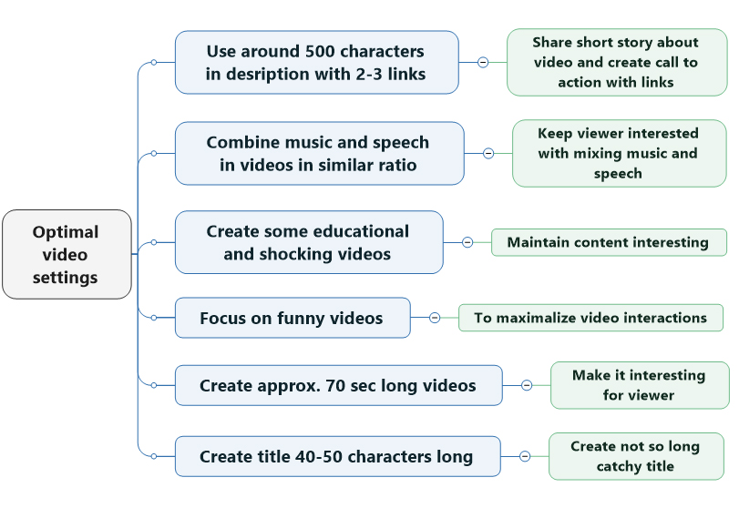

Figure 4 General recommendation for optimal airlines video settings.

# Conclusion

Except for the results presented in Figure 2 and Figure 3, there has not been proven in the selected sample convincing statistical correlation between the analysed variables (length of the video in seconds, number of characters in the video title, number of characters in the video description, search engine optimization score by software VidIQ, number of keywords used in the video, amount of music in the video, or number how many times camera switched to another screen) and the interactions per 1000 subscribers. If the selected variables (except video length) has not a great impact on the variable interactions per 1000 subscribers, what has the biggest impact on the interactions, on people liking, disliking and commenting on the video? It is the viewer age, gender nationality, actual feelings, or “*individual’s integration and relationship with the network and the attitudes towards viral messages*” (see model Camarero & San José, 2011)? There are countless variables that can influence the viral potential and a lot of articles across the world study it but it seems that this question is so complex and it has not been fully answered yet (see discussion in Wuebben, 2016).

When it comes to social media, companies and individuals are still learning and guidelines need update as frequently as social media strategy. The level of technology is exponentially increasing and therefore, it is hard to stay aware of marketing on social media, even social media is changing, new features are being added, more options for marketers and consumers being added and all of that create more variables in this viral issues. Further research should focus on the increasing number of successful airline companies on YouTube and their best videos, increasing number of variables connected to each video, which have some viral potential such as a rate of positive and negative words in videos, colours, and way of distribution to viewers. It is advisable to use the different methods of video analysis on YouTube - monitoring the history of their use with the analysis of the behaviour of individual users and virality dynamics (Khan & Vong, 2014; Braun et al., 2017), study user's motivations to pass online content (Ho & Dempsey, 2010; Khan, 2017), pay more attention to the role of emotion as a virality factor (Guadagno et al., 2013; Field, Riebe & Newstead, 2013) and make more detailed classification of videos by type of emotion (Chen, Chang & Yeh, 2017), and address the dynamics of their virality using the methodology described in France, Vaghefi, and Zhao (2016). It is clear that finding the algorithm of videos going viral is a complex problem, which have a probability features (France, Vaghefi, & Zhao, 2016).

It could be interesting to do a similar study, as we did for airlines, in other tourism services (hospitality, cruises, rent a car), or even other industry (electronic, furniture, etc.).

**Acknowledgment**: This work was supported by the FIM UHK under Grant of Specific Research Project “Information and knowledge management and cognitive science in tourism”.

References

1. Alloca K. (2011), “Why videos go viral?” TEDYouth 2011. Available at: <https://www.ted.com/talks/kevin_allocca_why_videos_go_viral/transcript>, (accessed 14 February 2019).
2. Ashley, Ch. and Tuten, T. (2014), “Creative Strategies in Social Media Marketing: An Exporatory Study of Branded Social Content and Consumer Engagement”, *Psychology and Marketing*, Vol. 32, No. 1, pp. 15-27.
3. Berthon, P., Pitt, L. and Campbell, C. (2008), “Ad lib: When customers create the ad”, *California Management Review*, Vol. 50, No. 4, pp. 6-30.
4. Braun, P. et al. (2017), “Enhanced Prediction of User-Preferred YouTube Videos Based on Cleaned Viewing Pattern History”, *Procedia Computer Science*, Vol. 112, pp. 2230-2239, doi: 10.1016/j.procs.2017.08.129.
5. Camarero, C. and San José, R. (2011), “Social and attitudinal determinants of viral marketing dynamics”, *Computers in Human Behavior*, Vol. 27, No. 6, pp. 2292-2300, doi: 10.1016/j.chb.2011.07.008.
6. Chen, Y.-L, Chang, Ch.-L. and Yeh, Ch.-S. (2017), “Emotion classification of YouTube videos”, *Decision Support Systems*, Vol. 101, pp. 40-50, doi: 10.1016/j.dss.2017.05.014.
7. Deighton, J. and Kornfeld, L. (2009), “Interactivity’s Unanticipated Consequences for Marketers and Marketing”, *Journal of Interactive Marketing*, Vol. 23, pp. 4-10.
8. France, S. L., Vaghefi, M. S. and Zhao, H. (2016), “Characterizing viral videos: Methodology and applications”, *Electronic Commerce Research and Applications*, Vol. 19, pp. 19-32, doi: 10.1016/j.elerap.2016.07.002.
9. Guadagno, R. E., Rempala, D. M., Murphy, S. and Okdie, B. M. (2013), “What makes a video go viral? An analysis of emotional contagion and Internet memes”, *Computers in Human Behavio*r, Vol. 29, No. 6, pp. 2312-2319, doi: 10.1016/j.chb.2013.04.016.
10. Handelman, J. (2006), “Corporate Identity and the Societal Constituent”, *Journal of the Academy of Marketing Science*, Vol. 34, pp. 107-114.
11. Ho, J. Y. C. and Dempsey, M. (2010), “Viral marketing: Motivations to forward online content”, *Journal of Business Researc*h, Vol. 63, No. 9–10, pp. 1000-1006, doi: 10.1016/j.jbusres.2008.08.010.
12. Keller, K. L. (1999), “Managing brands for the long run: Brand reinforcement and revitalization strategies”, *California Management Review*, Vol. 41, No. 3, pp. 102-124.
13. Keller, K. L. (2009), “Building strong brands in a modern marketing communications environment”, *Journal of Marketing Communications*, Vol. 15, No. 2/3, pp. 139-155, doi: 10.1080/13527260902757530.
14. Ketelaar, P. E. et al. (2016), “The success of viral ads: Social and attitudinal predictors of consumer pass-on behavior on social network sites”, *Journal of Business Research*, Vol. 69, No. 7, pp. 2603-2613, doi: 10.1016/j.jbusres.2015.10.151.
15. Ketter, E. and Avraham, E. (2012), “The social revolution of place marketing: The growing power of users in social media campaigns”, *Place Branding and Public Diplomacy*, Vol. 8, No. 4, pp. 285-294, doi: 10.1057/pb.2012.20.
16. Khan, F. G. and Vong, S. (2014), “Virality over YouTube: an empirical analysis”, *Internet Research*, Vol. 24, No. 5, pp. 629-647.
17. Khan, M. L. (2017), “Social media engagement: What motivates user participation and consumption on YouTube?”, *Computers in Human Behavior*, Vol. 66, pp. 236-247, doi: 10.1016/j.chb.2016.09.024.
18. Kirby, J. and Marsden, P. (2006), *Connected marketing: The viral, buzz and word of mouth revolution,* Great Britain: Butterworth-Heinemann.
19. Liikkanen, L. A. and Salovaara, A. (2015), “Music on YouTube: User engagement with traditional, user-appropriated and derivative videos”, *Computers in Human Behavior*, Vol. 50, pp. 108-124, doi: 10.1016/j.chb.2015.01.067.
20. Macdonald, E. and Wilson, H. (2012), *Best practice: Social Media Marketing*. Cranfield School of Management.
21. Murdough, Ch. (2009), “Social media measurement: It’s not impossible”, *Journal of Interactive Advertising*, Vol. 10, pp. 94-99.
22. Musa, H. et al. (2016), “Analyzing the Effectiveness of Social Media Marketing”, in *ISSC 2016: International Soft Science Conference*, *The European Proceedings of Social & Behavioural Science*, pp. 1 - 10, doi: 10.15405/epsbs.2016.08.2.
23. Nelson-Field, K., Riebe, E. and Newstead, K. (2013), “The emotions that drive viral video”, *Australasian Marketing Journal (AMJ)*, Vol. 21, No. 4, pp. 205-211, doi: 10.1016/j.ausmj.2013.07.003.
24. Pásková, M., Hruška, J. and Zelenka, J. (2018), “YouTube as an airlines marketing tool”, *Czech Journal of Tourism*, Vol. 7, No. 1, pp. 45-69, doi: 10.1515/cjot-2018-0003.
25. Payne, J. N., Campbell, C., Bal S. A. and Piercy, N. (2011), “Placing a Hand in the Fire: Assessing the Impact of a YouTube Experimential Learning Project on Viral Marketing Knowledge Acquisition”, *Journal of Marketing Education*, Vol. 33, No. 2, pp. 204-216.
26. Safko, L. and Brake, D. K. (2010), *The Social Media Bible: Tactics, Tools, and Strategies for Business Success*. New Jersey, USA: John Wiley & Sons, Inc.
27. Stephen, A. T. (2016), “The role of digital and social media marketing in consumer behaviour”, *Current Opinion in Psychology*, Vol. 10, pp. 17-21.
28. Thackeray, R., Neiger, B. L., Hanson, C. L. and McKenzie, J. F. (2008), “Enhancing Promotional Strategies within Social Marketing Programs: Use of Web 2.0 Social Media”, *Health Promotion Practice*, Vol. 9, 338-343.
29. Tuten, T. L. and Solomon, M. (2013), *Social media marketing*. SAGE Publications Ltd.
30. Wang, Y., Yu, Q. and Fesenmaier, D. R. (2002), “Defining the virtual tourist community: implications for tourism marketing”, *Tourism Management*, Vol. 23, pp. 407–417.
31. Wardhana, A. and Pradana, M. (2016), “Viral marketing determinants of the top online shop brands in Indonesia”, *Mimbar*, Vol. 32, No. 1, pp. 25-30, doi: 10.29313/mimbar.v32i1.1572.
32. Wu, J., Chiclana, F., Fujita, H. and Herrera-Viedma, E. (2017), “A visual-interaction-consensus-model for social network group decision making with trust propagation”, *Knowledge-Based Systems*. Vol. 122, pp. 39-50.
33. Wuebben, D. (2016), “Getting Likes, Going Viral, and the Intersections between Popularity Metrics and Digital Composition”, *Computers and Composition*, Vol. 42, pp. 66-79, doi: 10.1016/j.compcom.2016.08.004.
34. Zelenka, J. and Hruška, J. (2018a), “YouTube in Airlines Marketing”, in *Proceedings of Hradec economic days 2018,* Hradec Králové: Gaudeamus, pp. 514-526.
35. Zelenka, J. and Hruška, J. (2018b), “Ways and effectiveness of social media utilization by airlines. Tourism: An International Interdisciplinary Journal”, Vol. 66, No. 2, pp. 227-238.
36. Zhu, Y.-Q. and Chen, H.-G. (2015), “Social media and human need satisfaction: Implications for social media marketing”. *Business Horizons*, Vol. 58, No. 3, pp. 335–345. doi:10.1016/j.bushor.2015.01.006.